CS – GY 6923 Machine Learning

*Professor: Dr. Raman Kannan*

HW3: Ensemble Methods

Avinash Authipudi

**Section 1 – Review of the Classifiers**

In the previous assignment, we ran 5 classifiers on 2 of our datasets (Dataset1 and Dataset2) and summarized the results. We also found that Decision Tree classifier worked the best on our datasets. We also analyzed what the variance of the different models.

We now proceed to use Ensemble techniques to improve performance of the classification algorithms run on our datasets. In this assignment, we have chosen the following Ensemble Methods:

1. Random Forest
2. Stacking with CV
3. Bagging with CV

We club ensemble methods Stacking and Cross validation in training the Logistic Regression, Decision Trees and KNN classifier models before combining them for prediction.

Since the datasets have a large number of observations, it takes a lot of computing time when algorithms are run on them. Hence, we make use of the parallel computation feature in R which can be seen in the below sections of the assignment. We also create threads that execute parallelly to decrease computation time.

**Section 2 – Random Forest Method**

The first Ensemble method we run is the Random Forest method which is based on decision tree algorithm. The implementation is as shown below.

Training Phase of Random Forest on Dataset1(ntree=500):

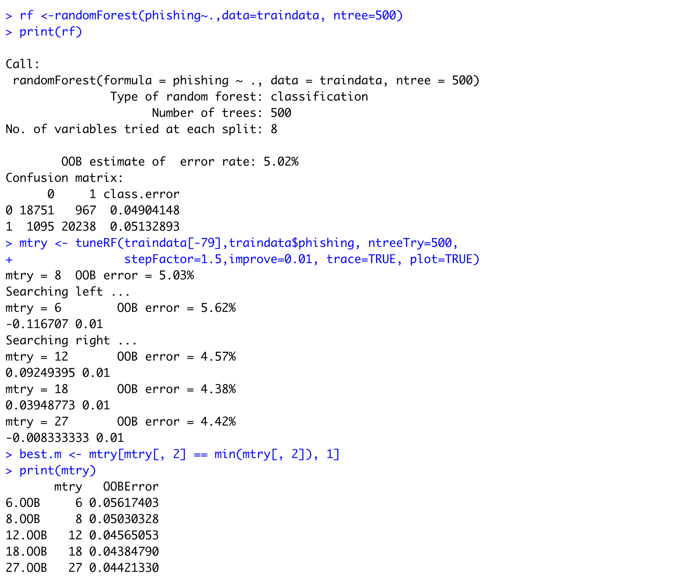

Once the initial model is run, we tune the model to find the least Out of Bag error rate. The m value related to the least OOB error is chosen in training the model again. This highly reduces correlation. We also have set ntree to 500 which is usually the default value. We have assumed a higher value of ntree since random forest models do not overfit very easily.

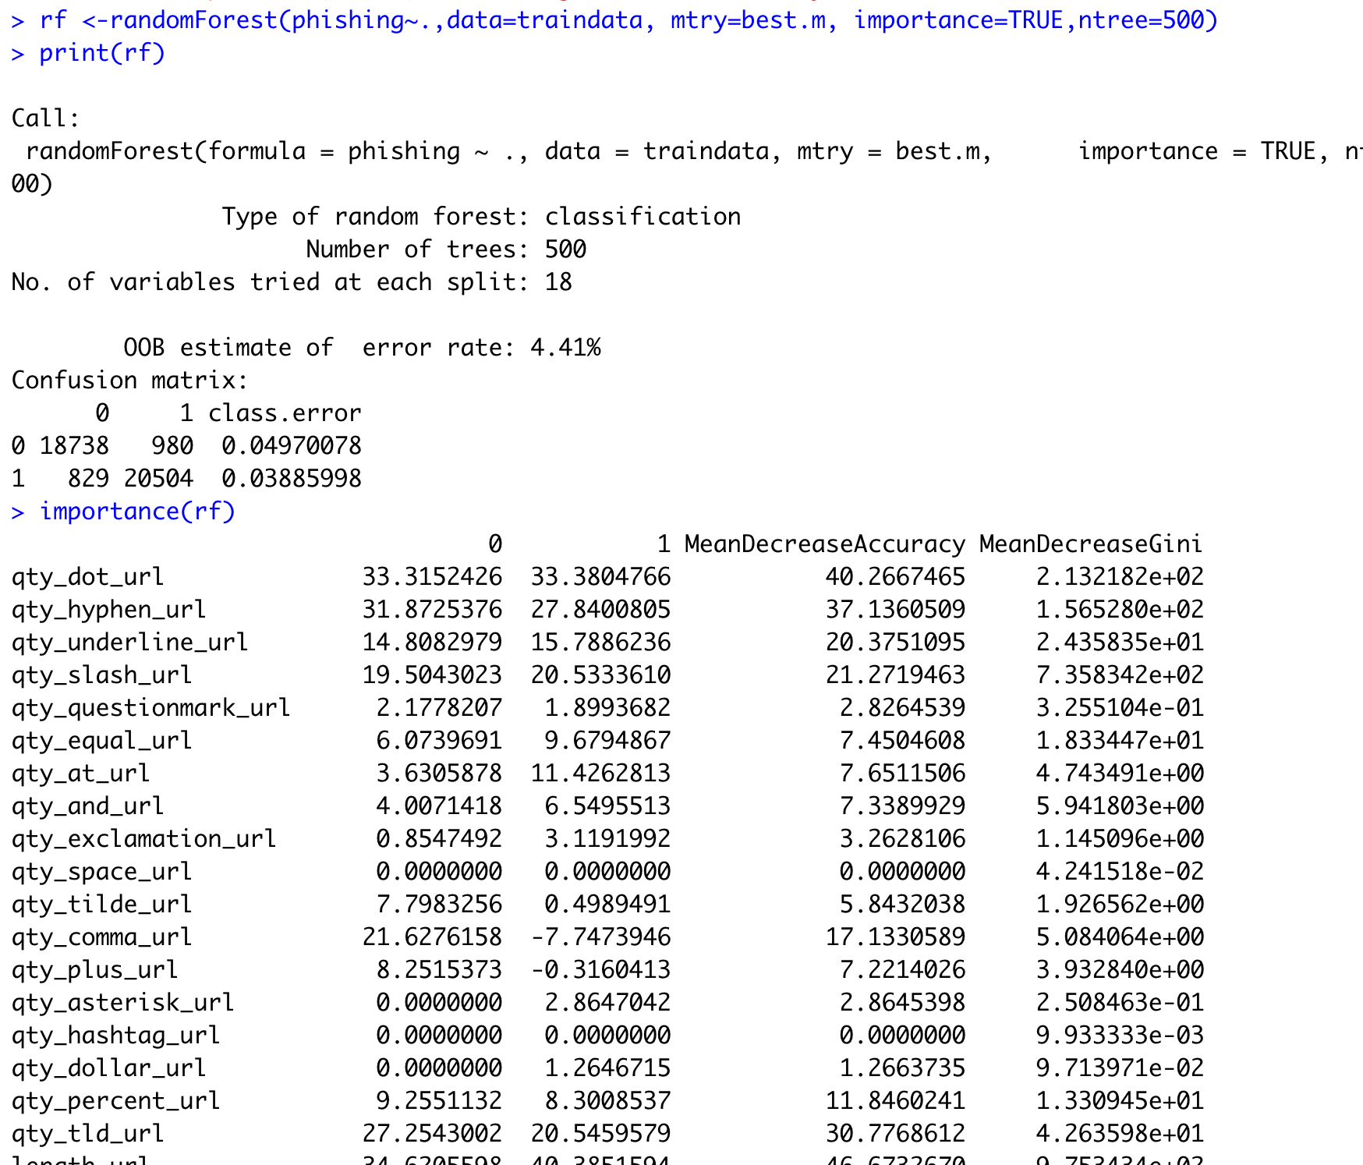

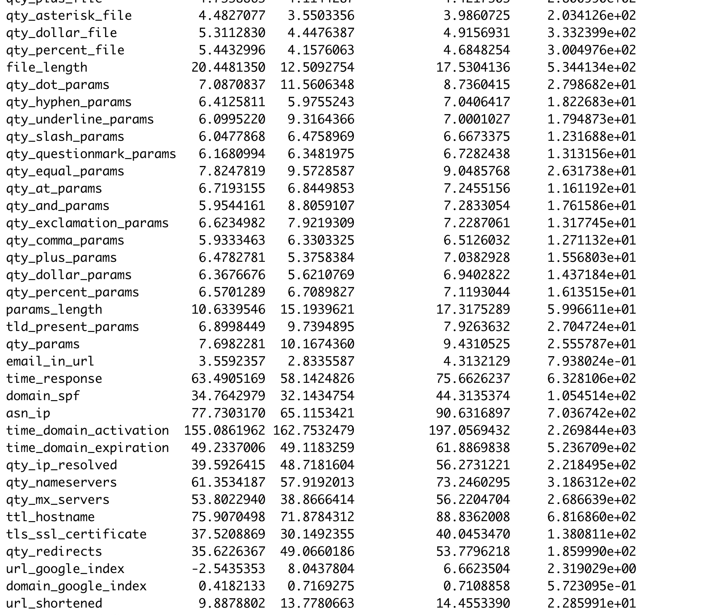

Training Phase Confusion Matrix for Dataset1:

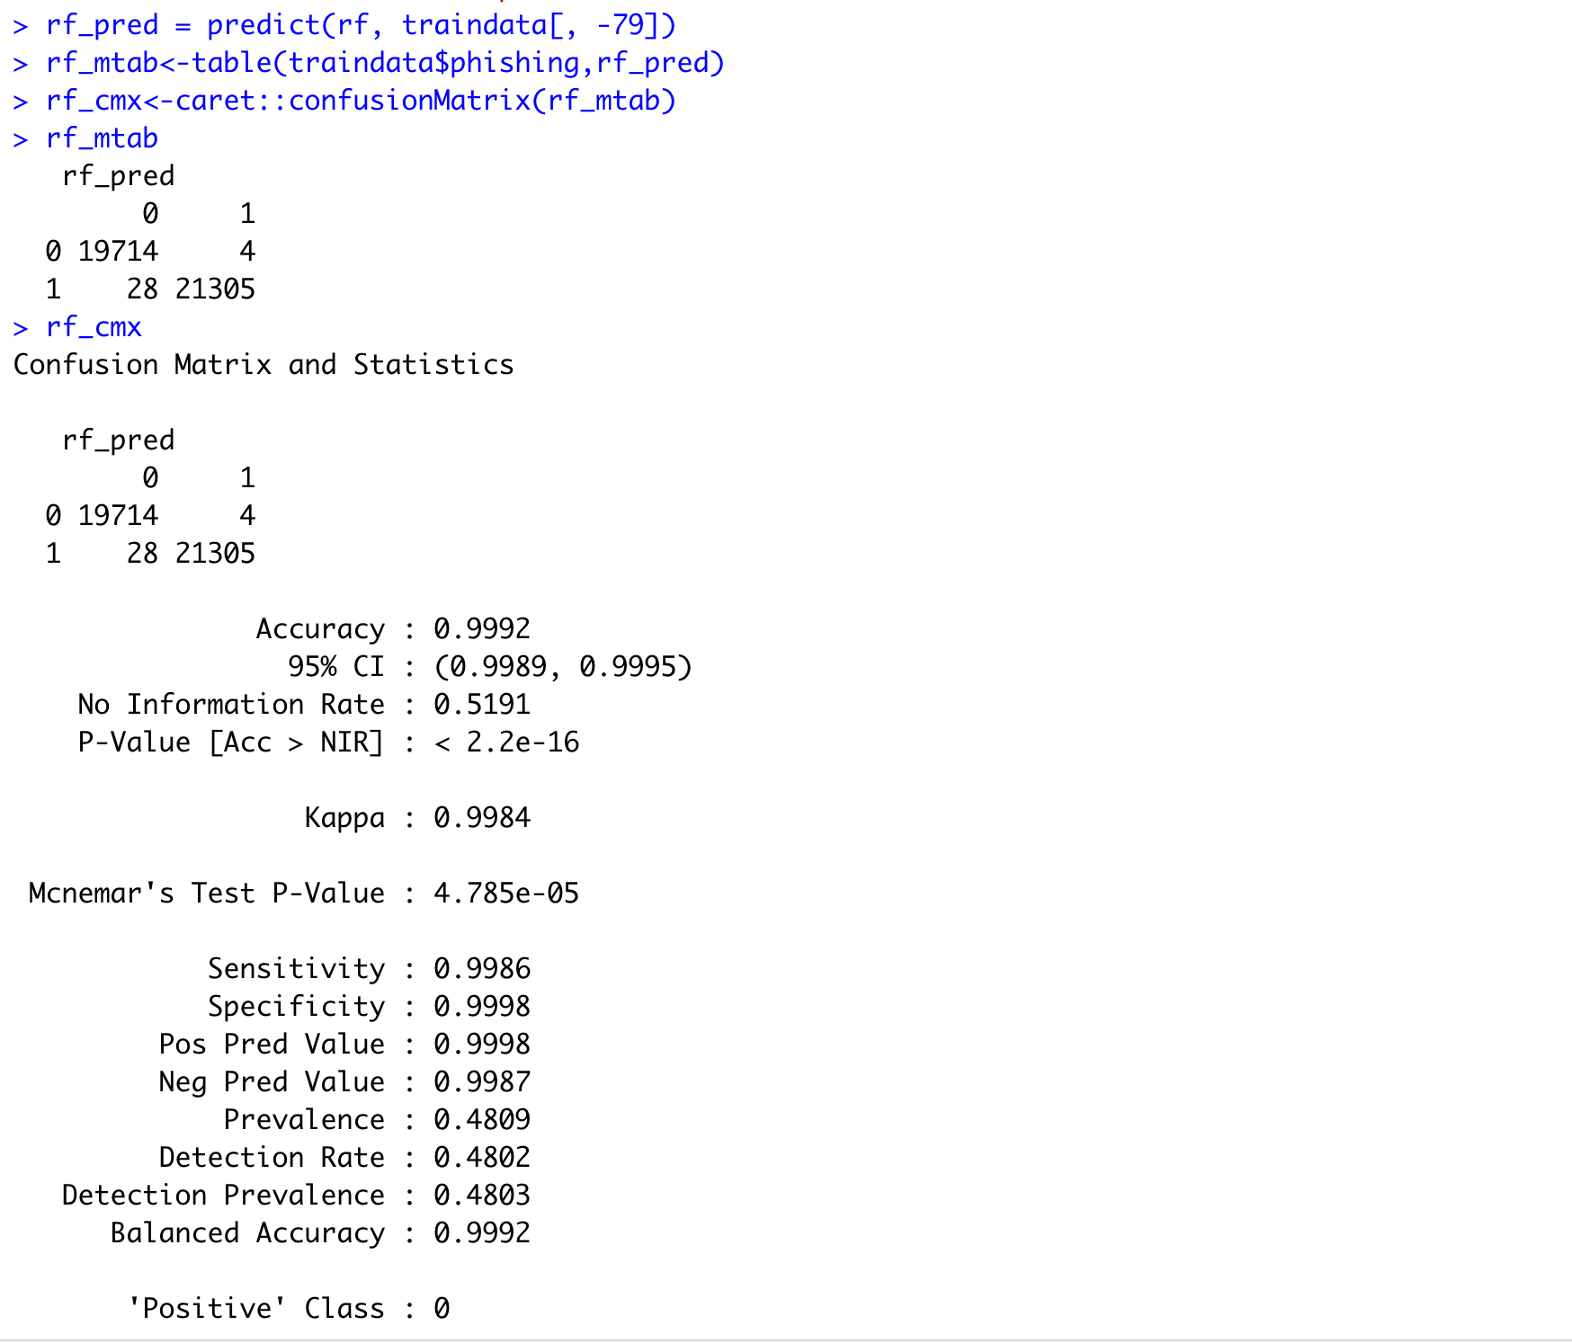

Performance Metrics from the Training Phase of Dataset1:

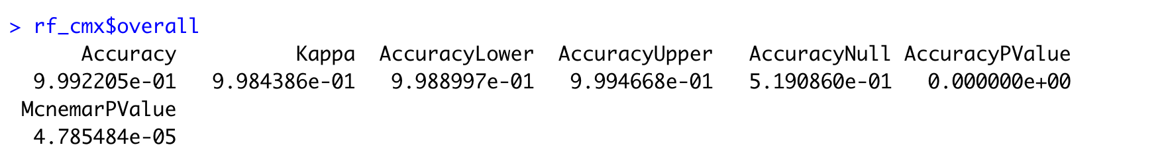





The above metrics indicate that the model trained extremely good and we can expect good accuracy from the testing phase.

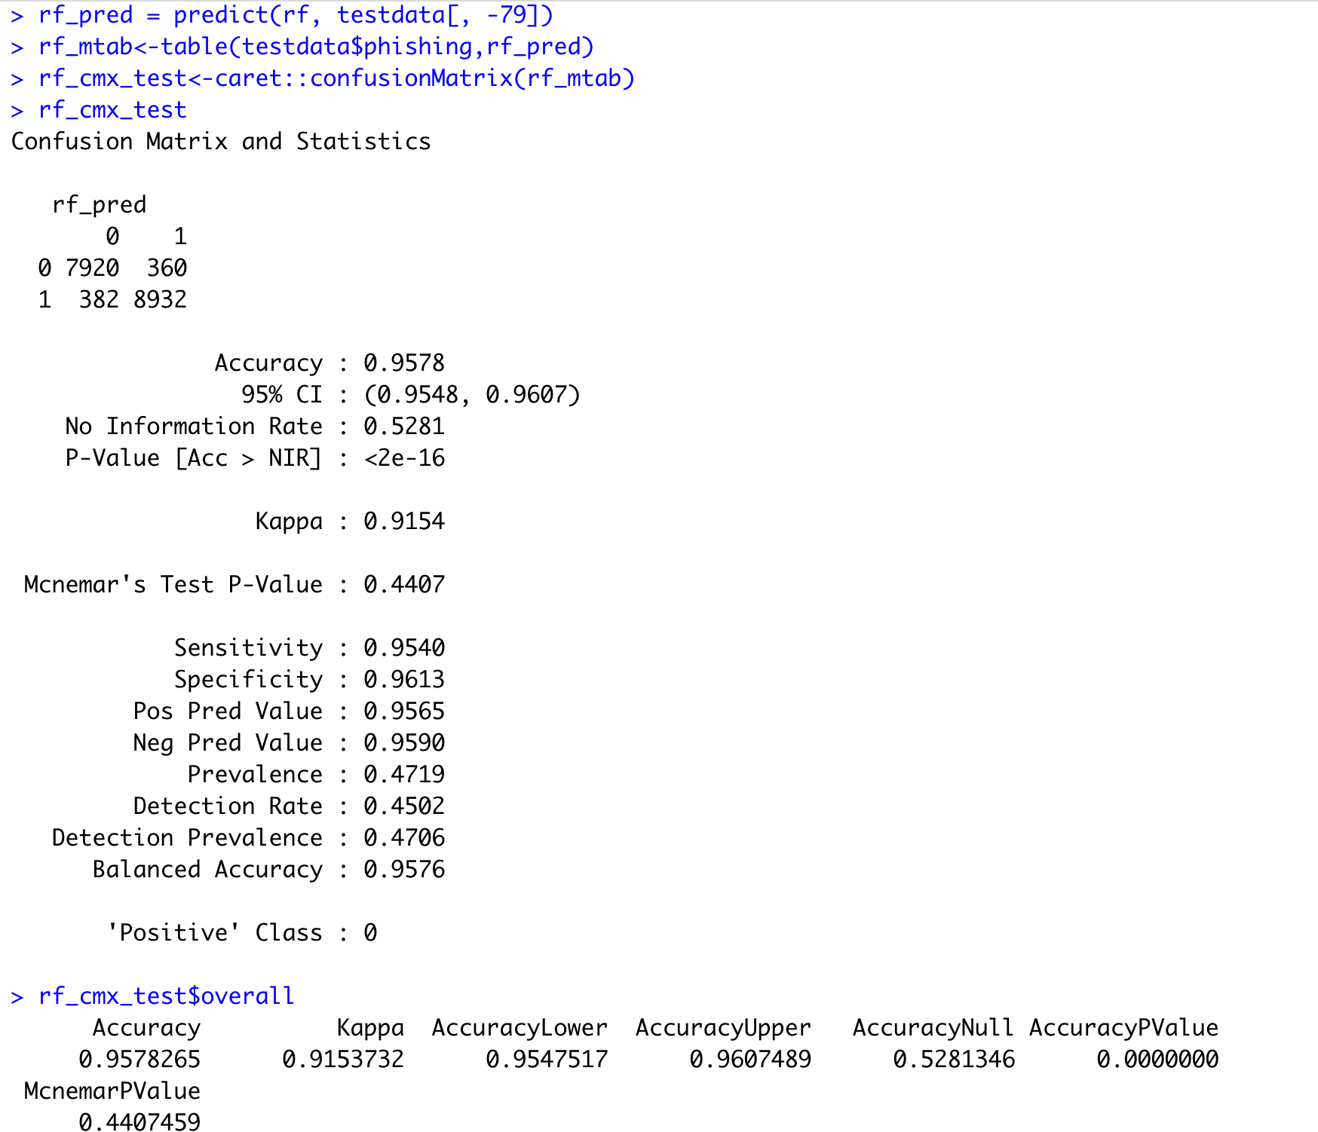

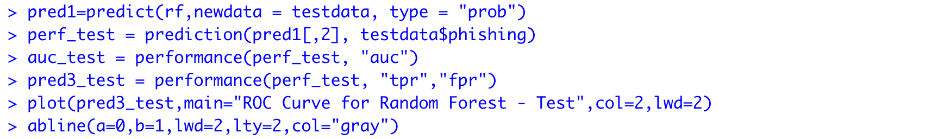

The above snippets indicate the accuracy of the model which is a significant improvement over all our previously run classification models.

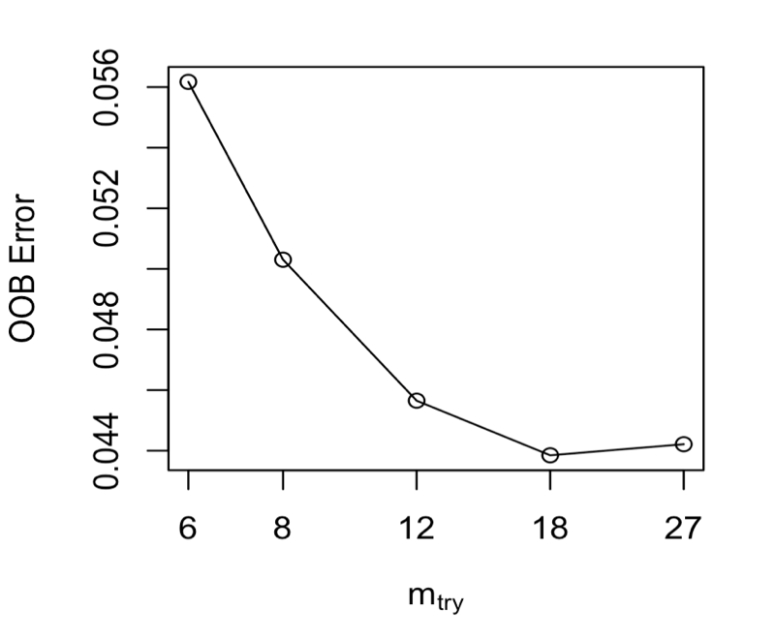

Fig: OOB vs M-try Graph for ntree=500

(Training Phase)

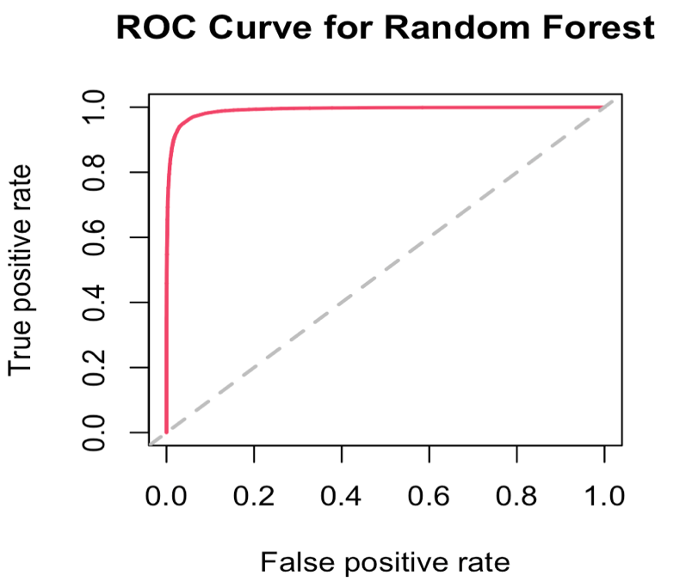

Fig: ROC Curve for Learning Phase

(Dataset1)

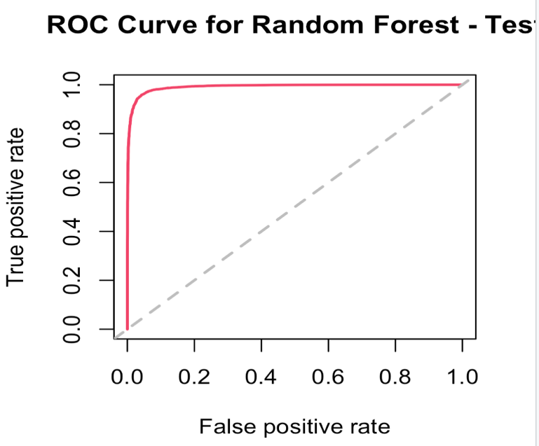

Fig: ROC Curve for the Testing Phase

(Dataset1)

Random Forest Model on Dataset2:

The same procedure is repeated for the smaller variant of the dataset which has lesser number of features. The implementation is as shown below:

Learning Phase of Random Forest Model on Dataset2:

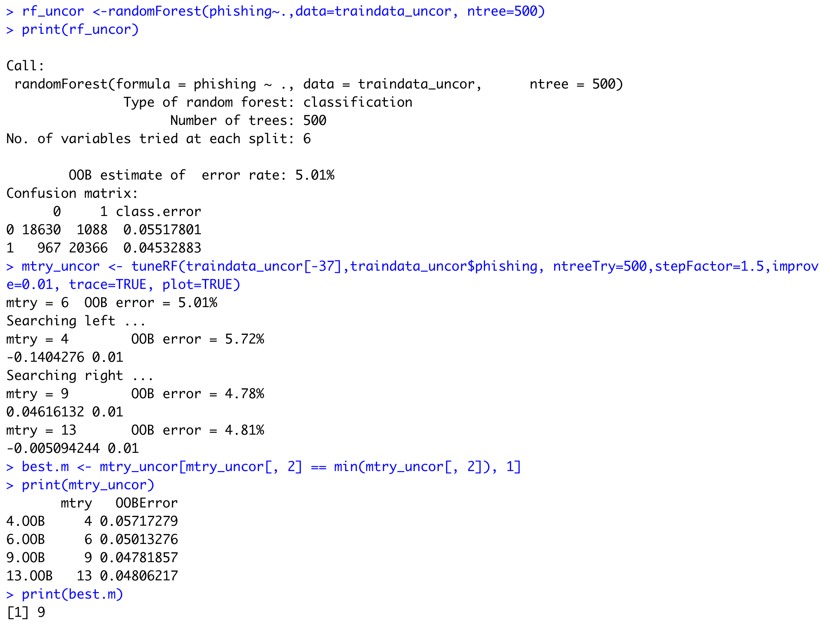

The best value for mtry is 9 where the OOB error rate is the least. Here as well, we choose ntree as 500.

Confusion Matrix for the Learning Phase:

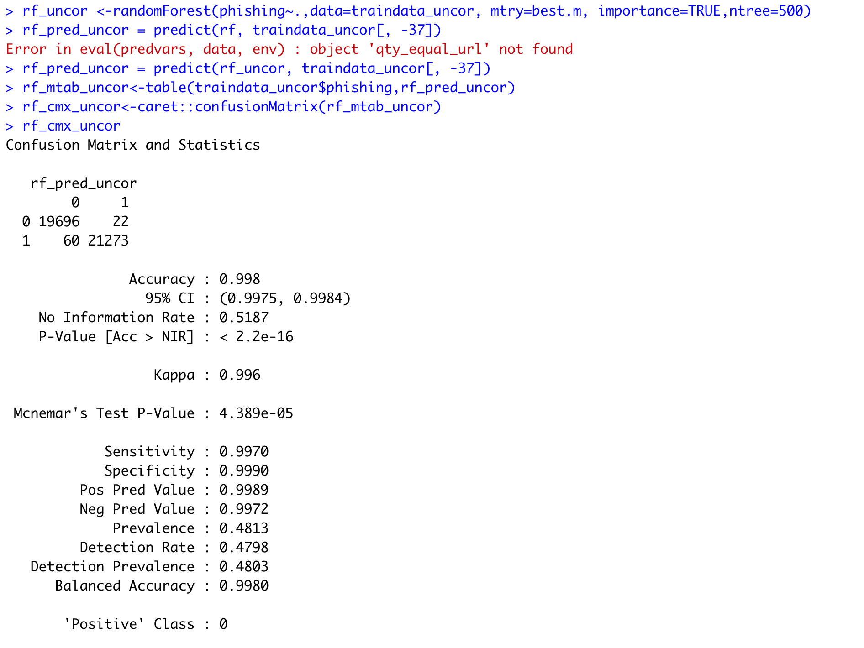

Confusion Matrix for the Testing Phase:

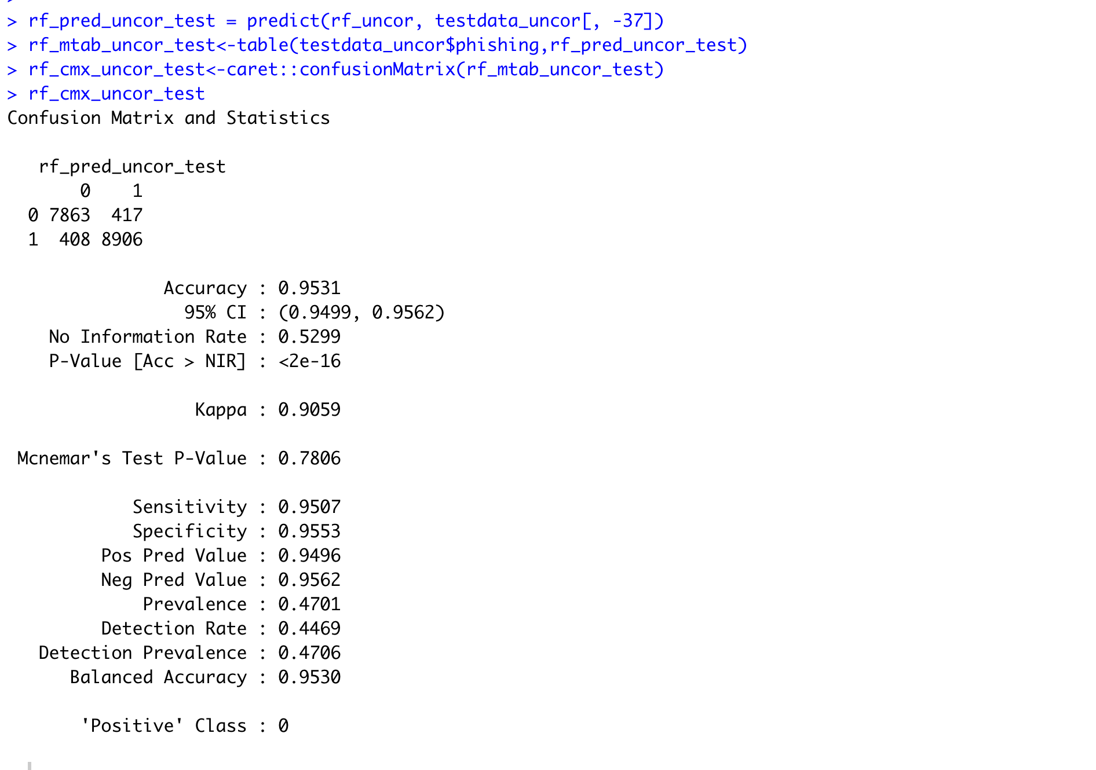

Performance Metrics of the Training and Testing phases of the Random Forest Model on Dataset2:

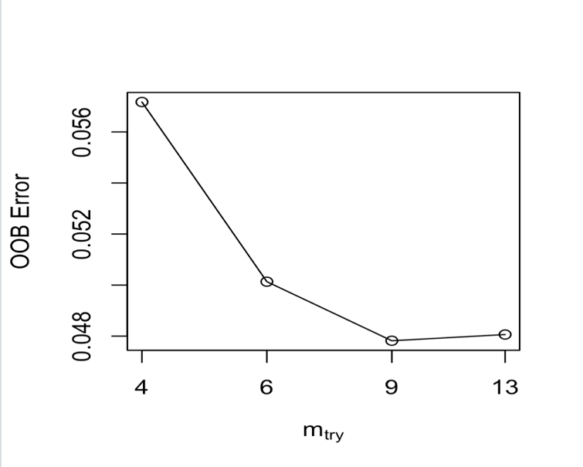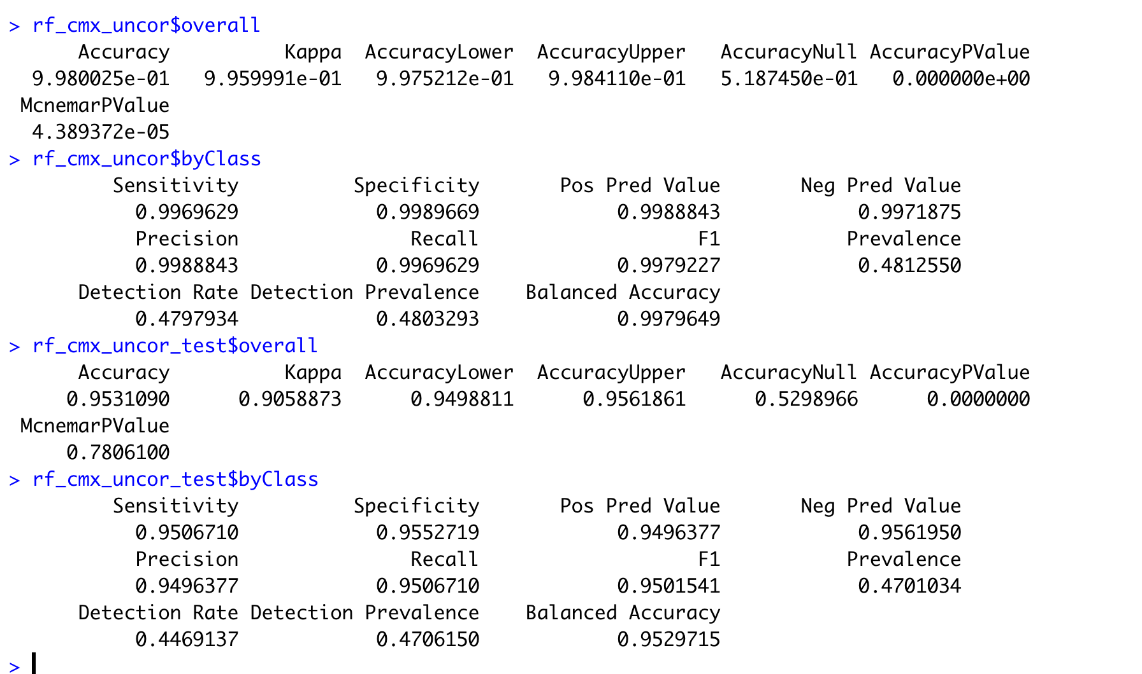

Fig: OOb vs Mtry graph for Dataset2

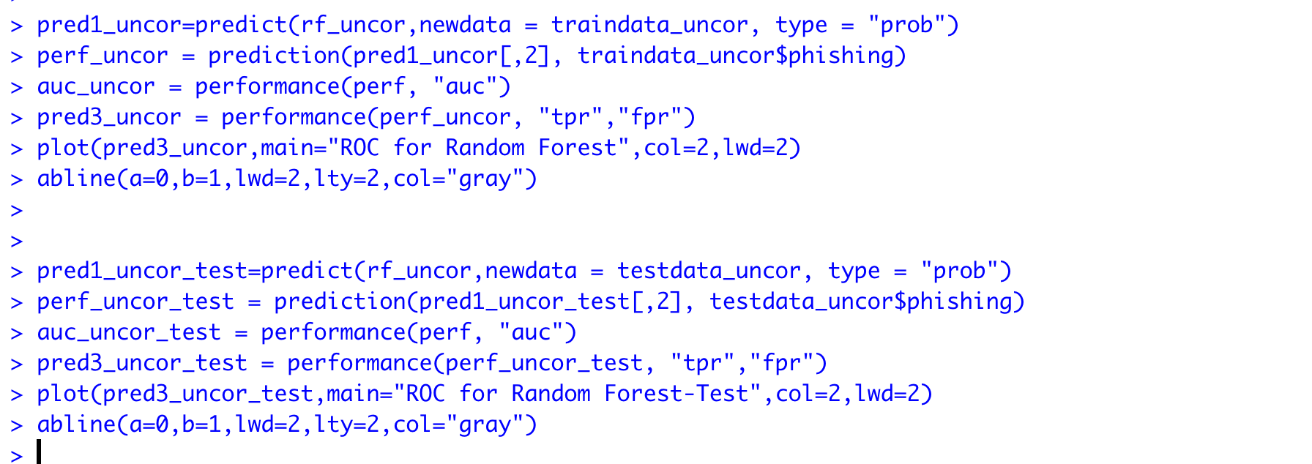

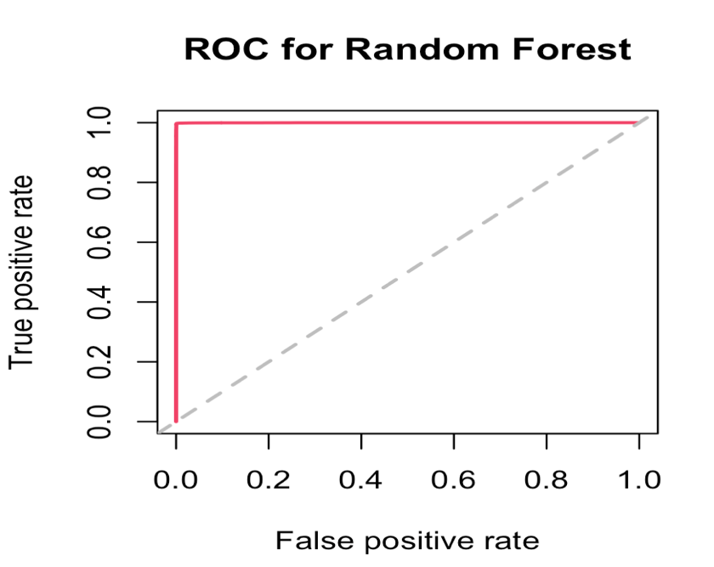

Fig: ROC Curve for the Training Phase

(Dataset2)

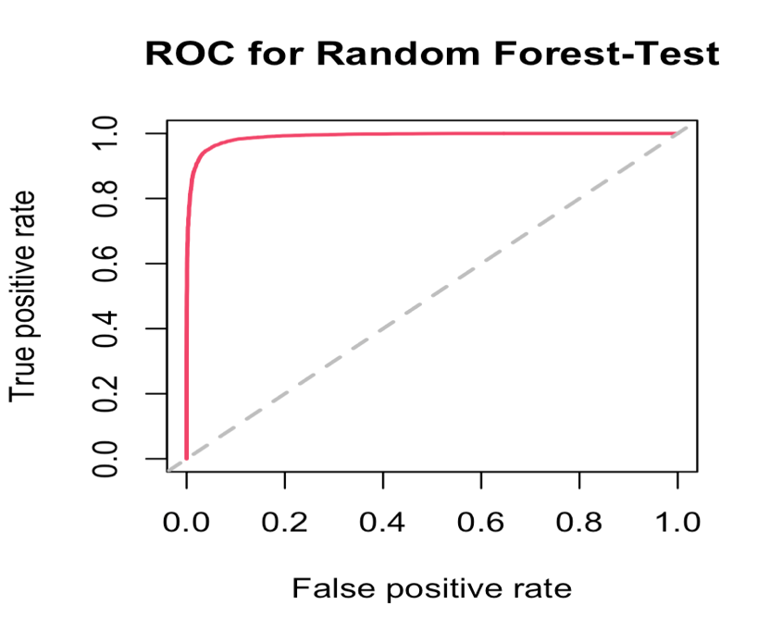

Fig: ROC Curve for the Testing Phase

(Dataset2)

We repeat the same process now by setting ntree=100. The implementation is given below:

Training Phase of Random Forest on Dataset1(ntree=100):

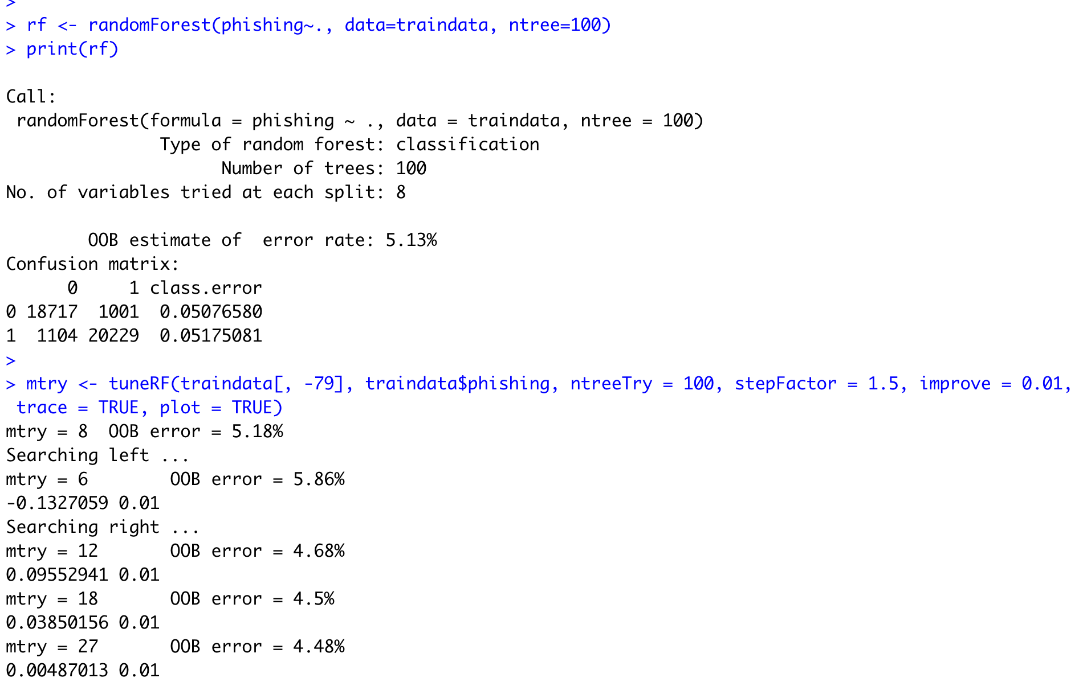

We calculate the best Mtry which has the least OOB error rate as shown below.

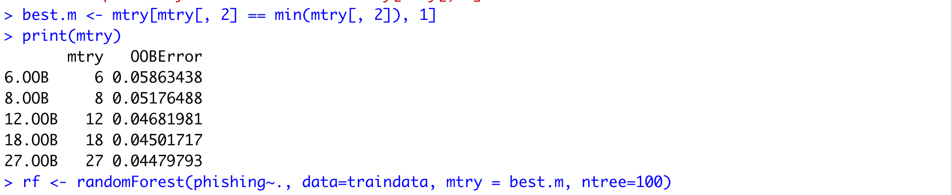

Learning Phase Confusion Matrix for Dataset1

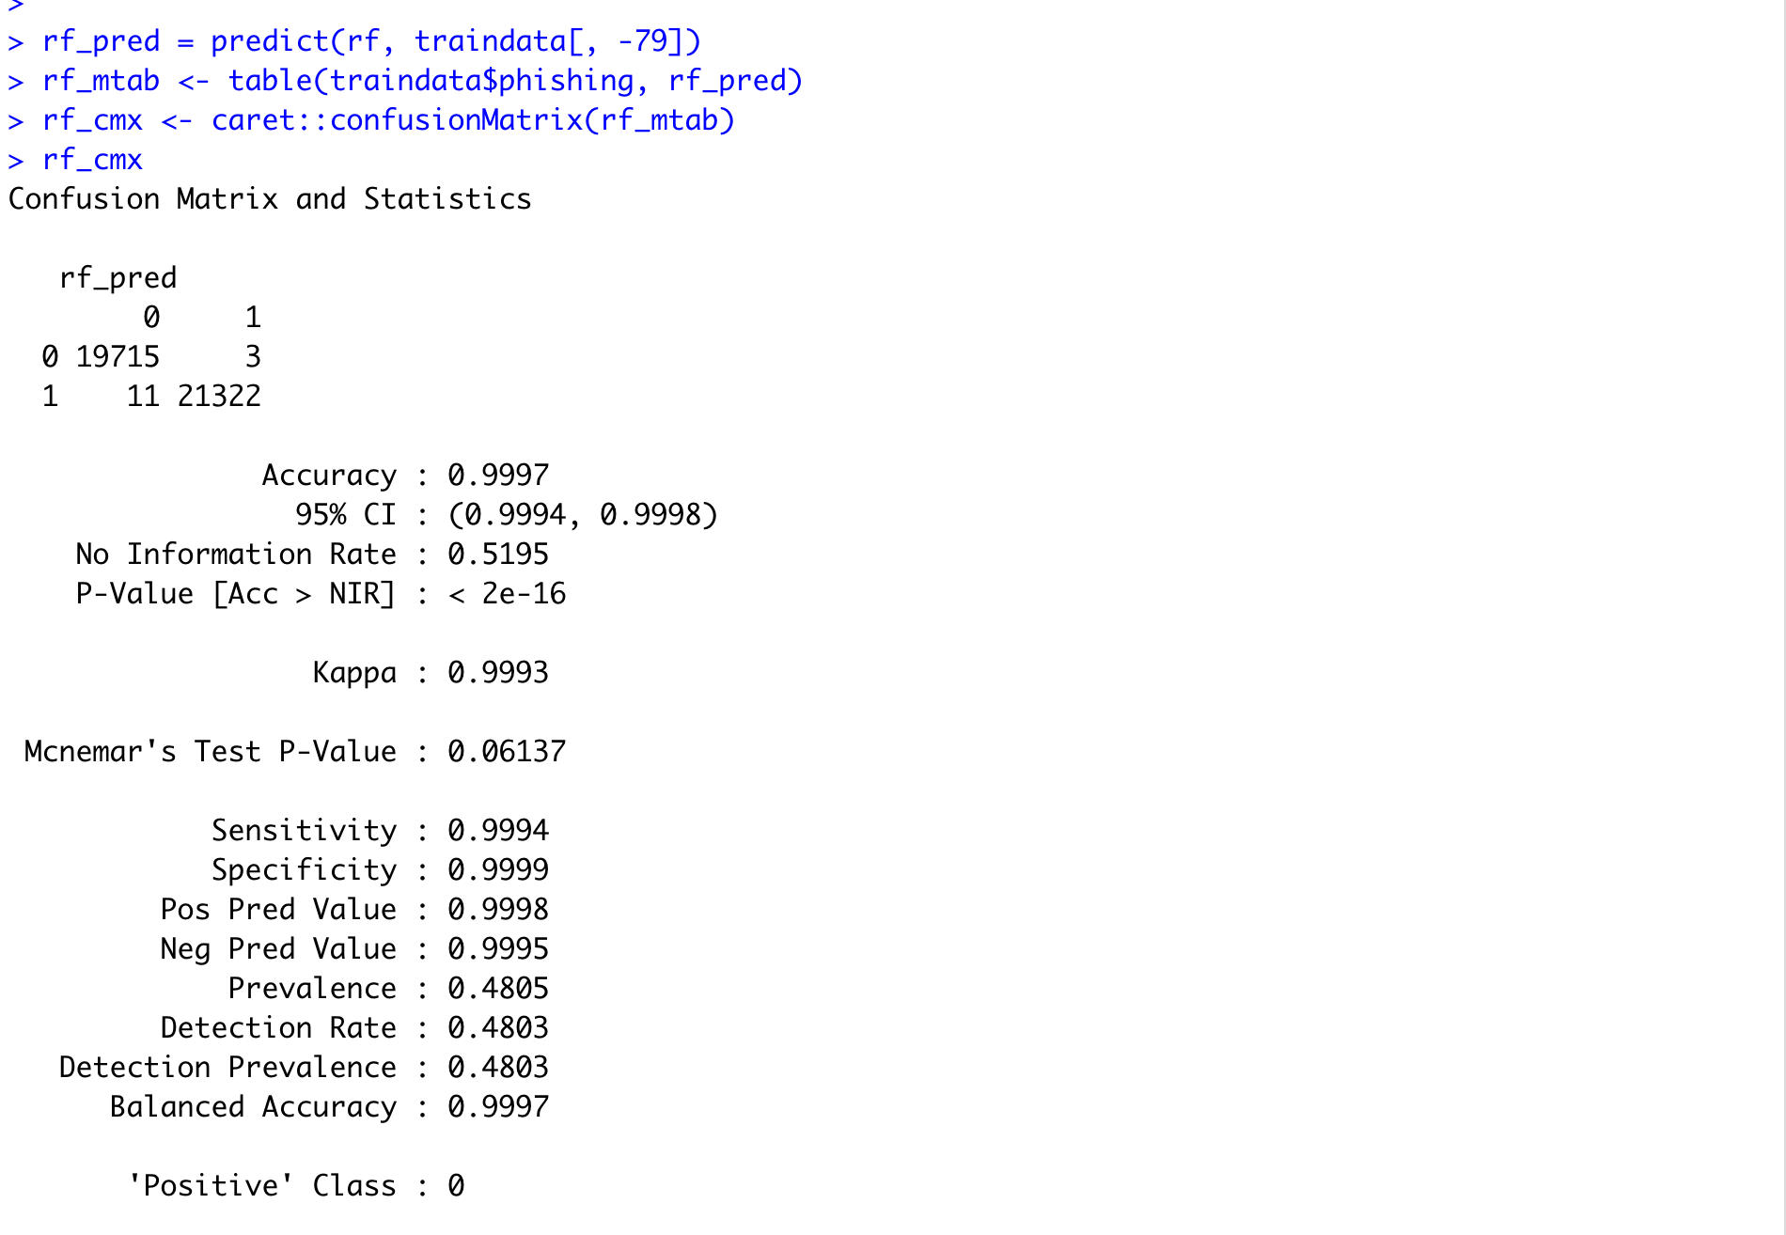

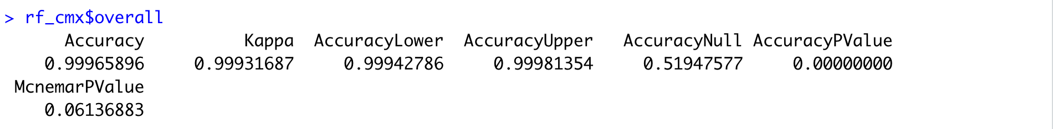

The performance metrics are as indicated above. The model accuracy indicates a very good fit.

Testing Phase Confusion Matrix for Dataset1:

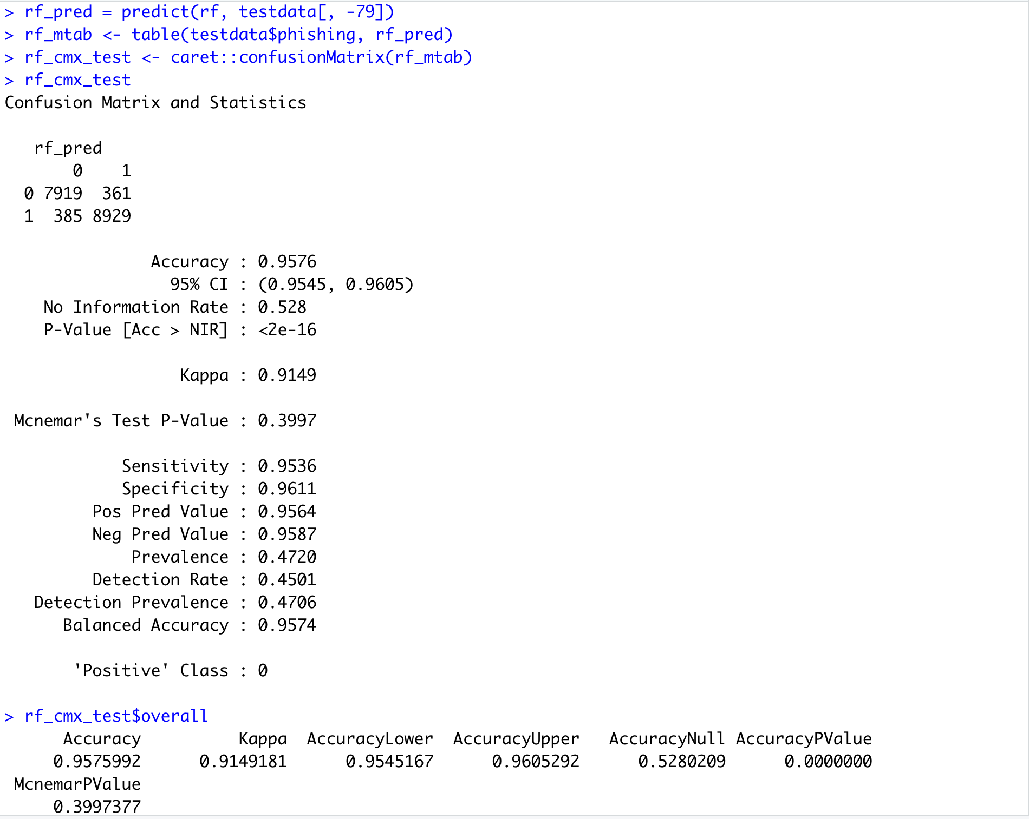

We repeat the process over the smaller version of the dataset.

Learning Phase for Dataset2:

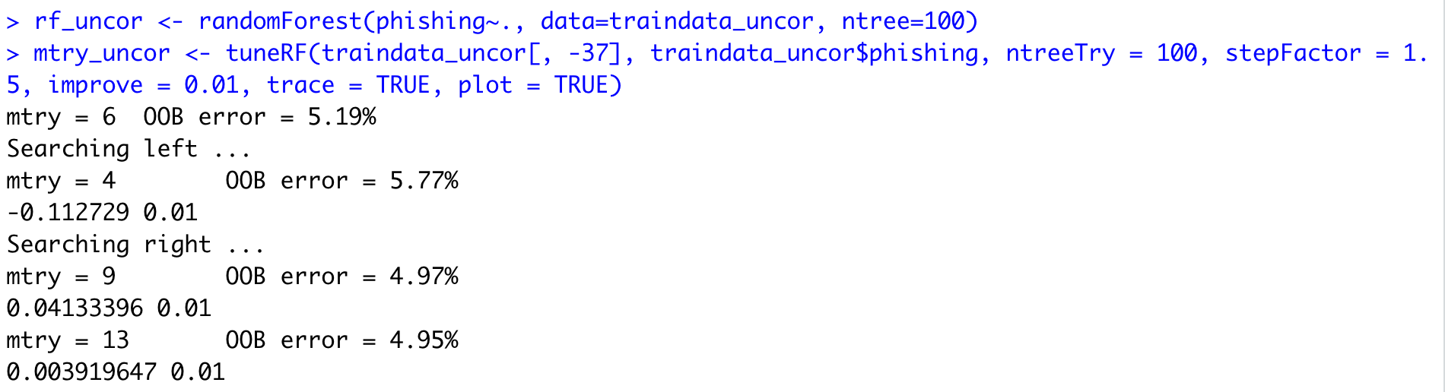

Learning Phase Confusion Matrix for Dataset2:

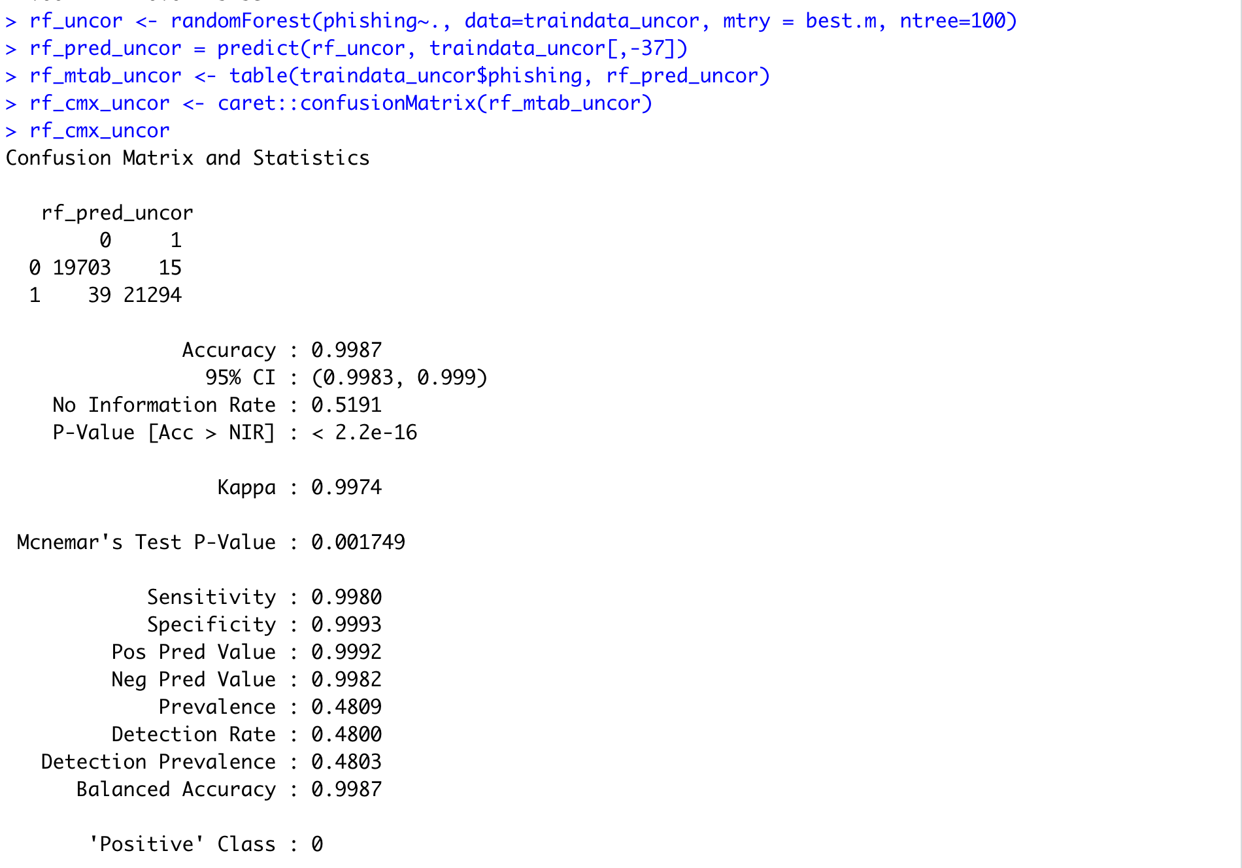

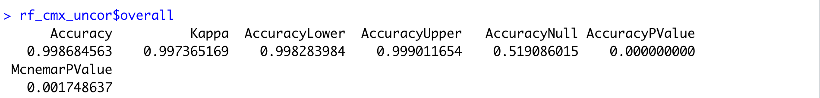

The performance indicated above implies a very good fit of the model.

Testing Phase Confusion Matrix for Dataset2:

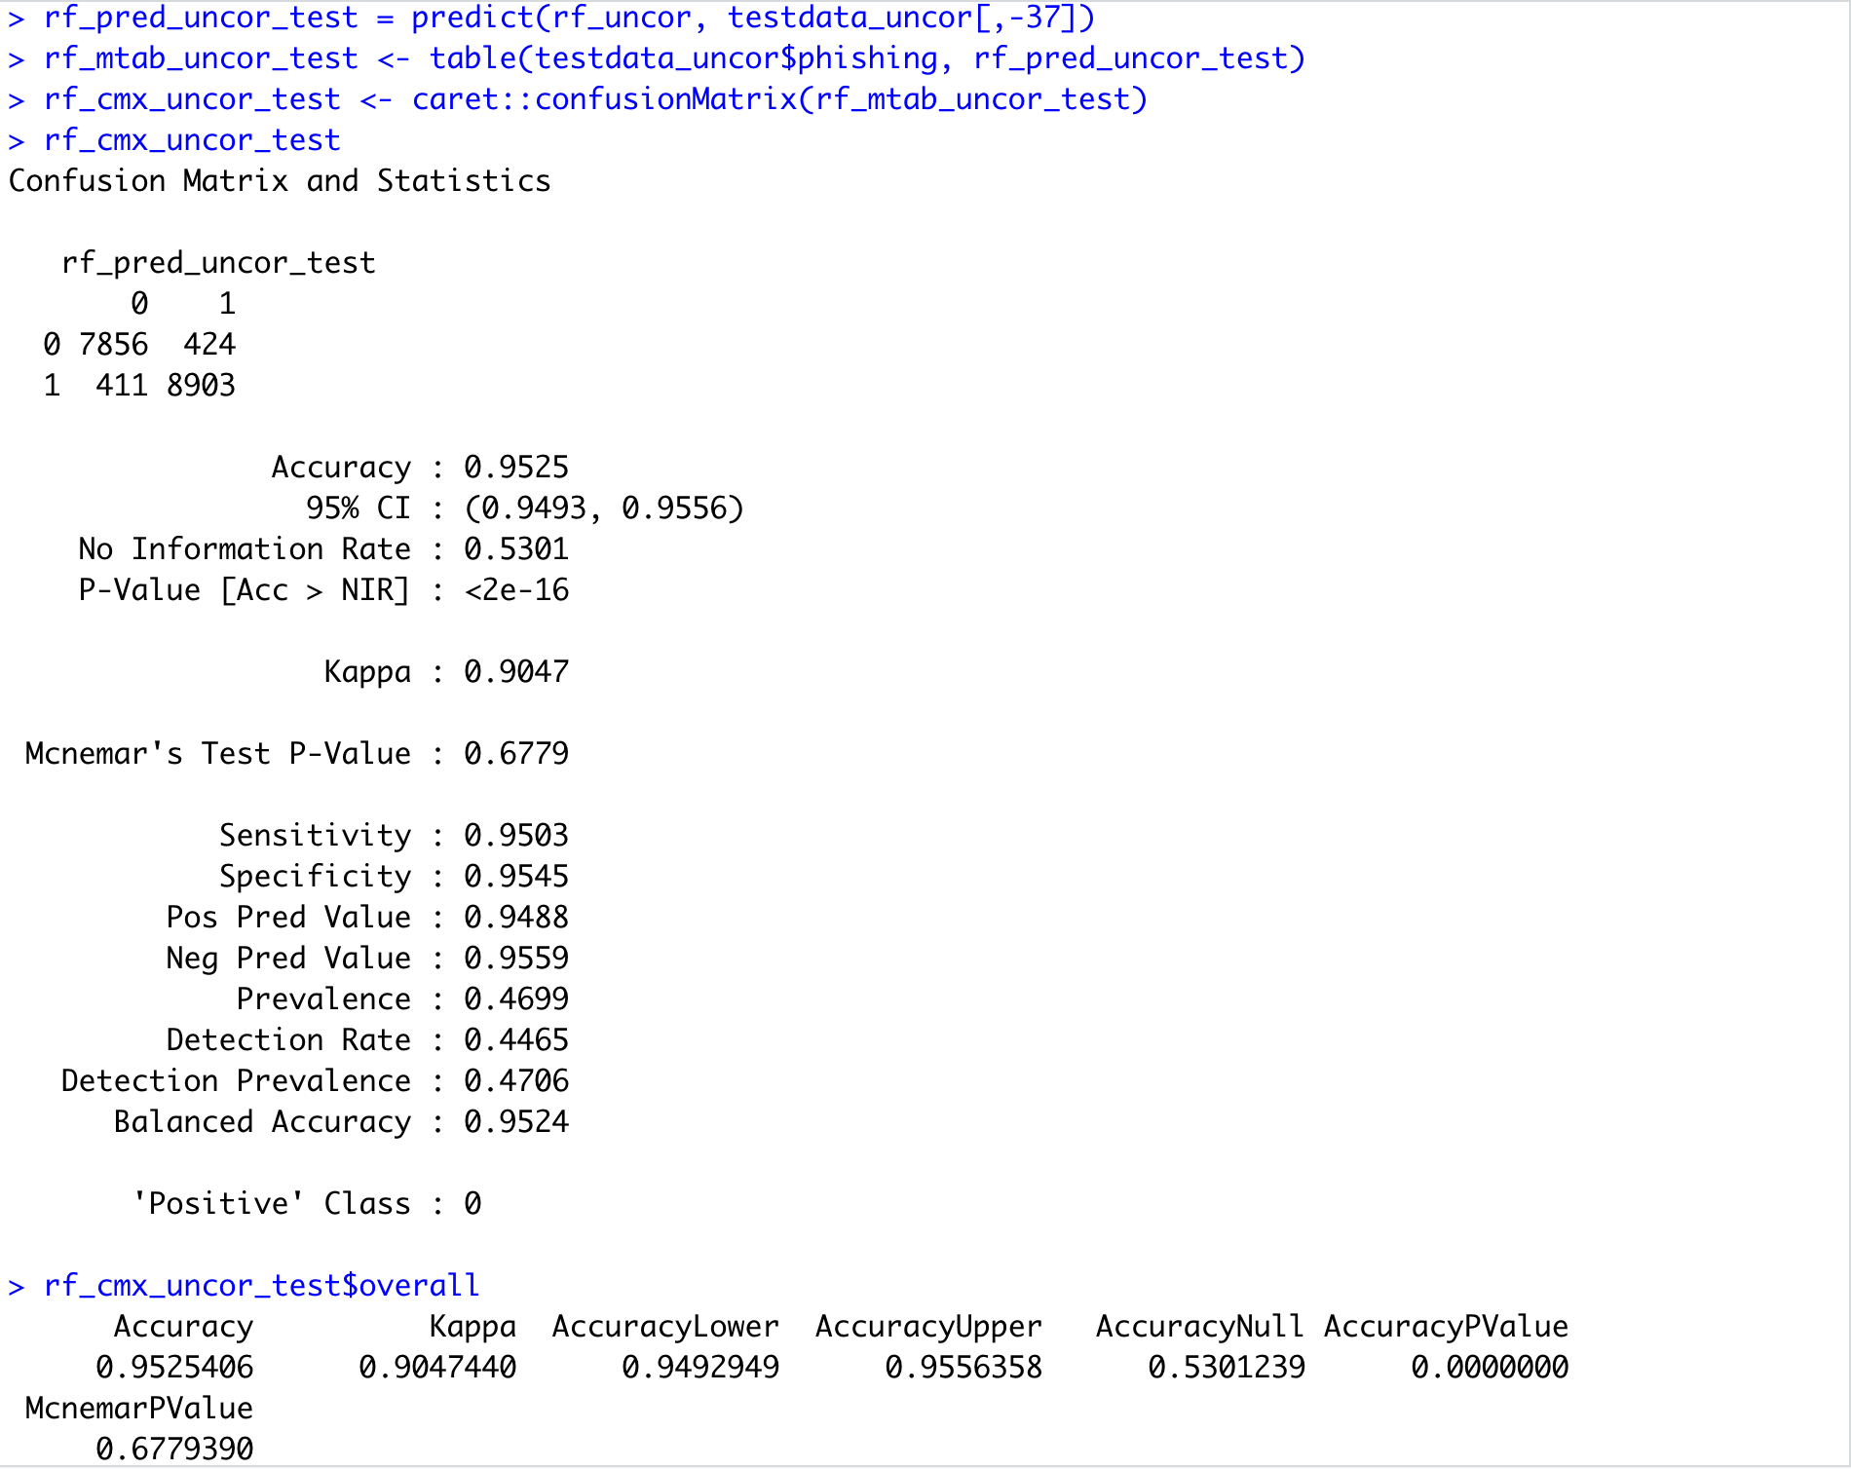

The performance metrics are indicated above. When we contrast the accuracy of the Random Forest Model run using ntree=500 and ntree=100, we can conclude that there is no significant increase in terms of accuracy or other performance metrics. Hence we conclude the Random Forest Model and note down the accuracy.

**Section 3 – Stacking with 5-fold Cross Validation**

We club the ensemble methods Stacking and Cross Validation to boost the performance of the classifiers. Here we first split the dataset into training and testing partitions. We then use the training partition to run 3 different classifiers which is Logistic Regression, KNN and Decision Trees to train the partition. The method trainControl uses cross validation in training the best performing model. After this, we club the results of the 3 classifiers into a dataframe and again train the entire result using Decision Trees.

library(parallel)

library(doParallel)

cluster <- makeCluster(detectCores() - 1)

registerDoParallel(cluster)

fitControl <- trainControl(method = "cv",number = 5, allowParallel = TRUE)



system.time(modelFitLR <- train(phishing ~ ., method="glm",data=training, trControl = fitControl))

system.time(modelFitKNN <- train(phishing ~ ., method="knn",data=training, trControl = fitControl))

system.time(modelFitRpart <- train(phishing ~ ., method="rpart",data=training, trControl = fitControl))

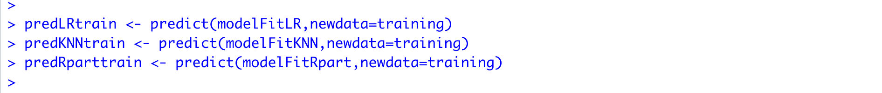





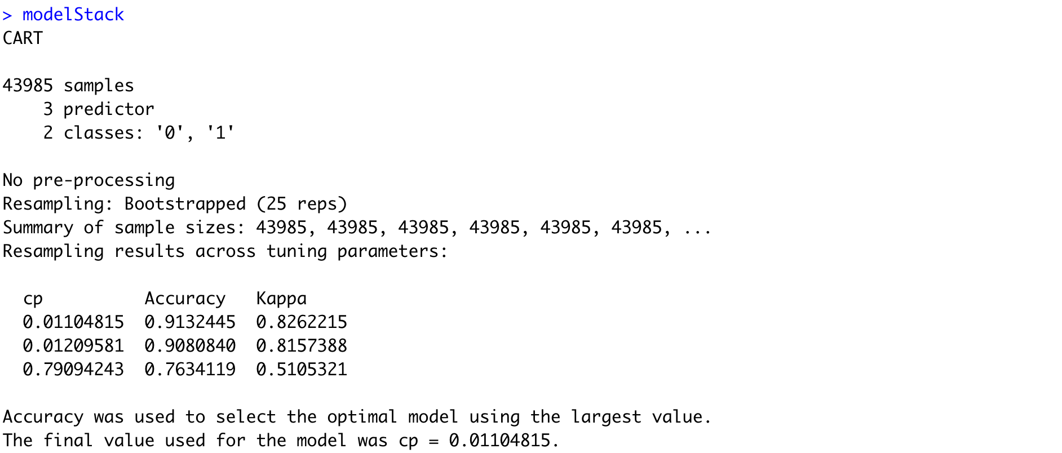

The testing partition is also predicted with the 3 classifiers and clubbed as a single data frame. Finally, the result of the final classifier on the union of the 3 classifier outputs is used to predict the testing data frame obtained.

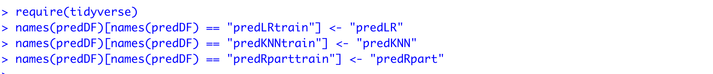



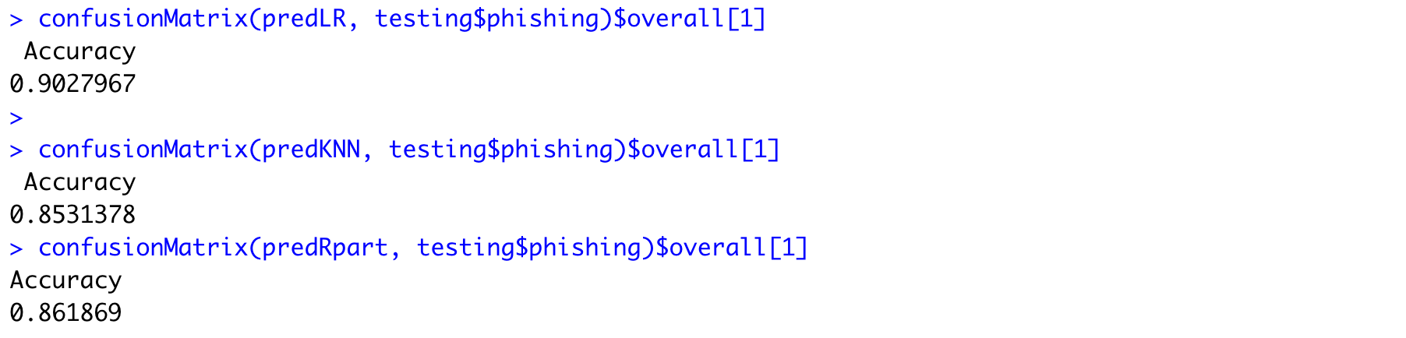

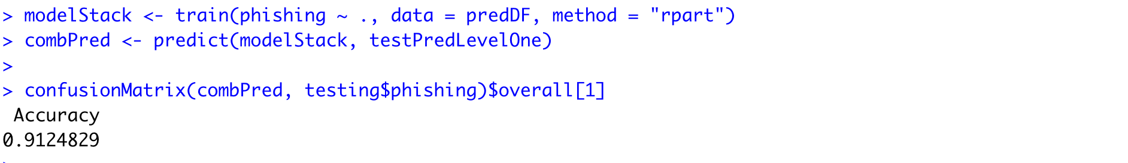

As seen above, the accuracy is very good compared to the individual classifier accuracies.

The same procedure is done with the smaller dataset and the accuracy is measured.

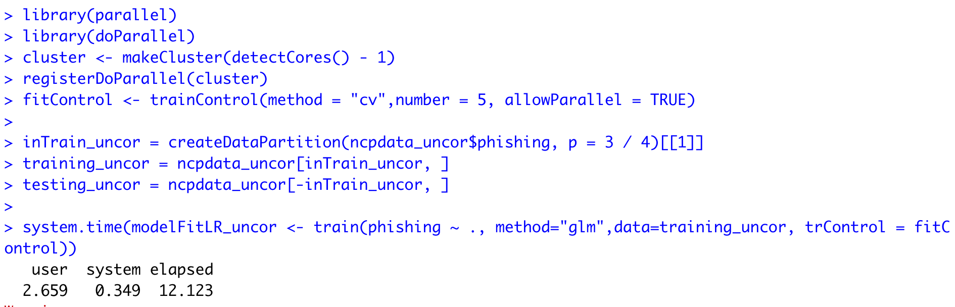

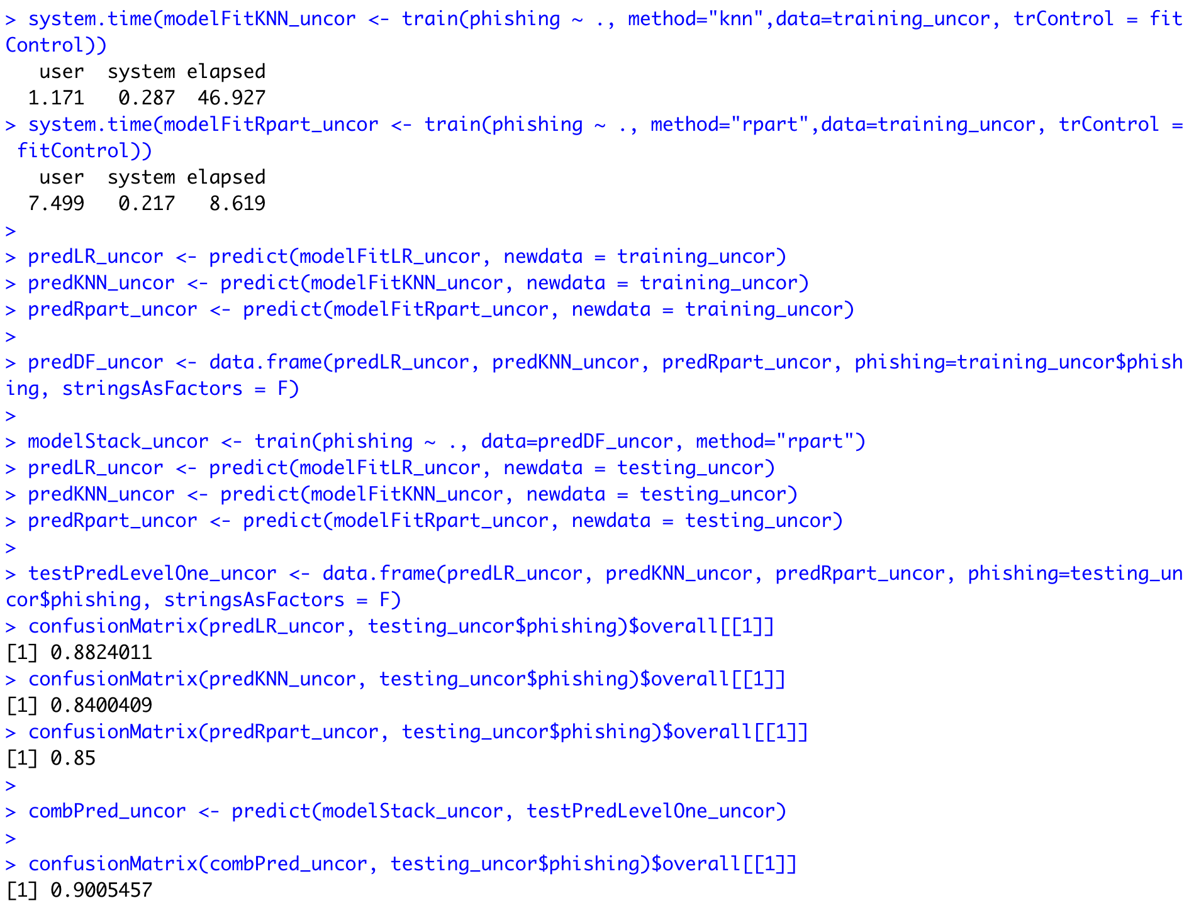

The result of the stacking ensemble method run on the second dataset is also very good compared to the individual classifier accuracies.

**Section 4 – Bagging with 5-fold Cross Validation**

The next ensemble method we see is bagging. We use “parallel” and “doParallel” packages in R to use parallel computation. The below implementation shows bagging applied on our 2 datasets using “treebag” method.

Learning Phase Bagging on Dataset1:

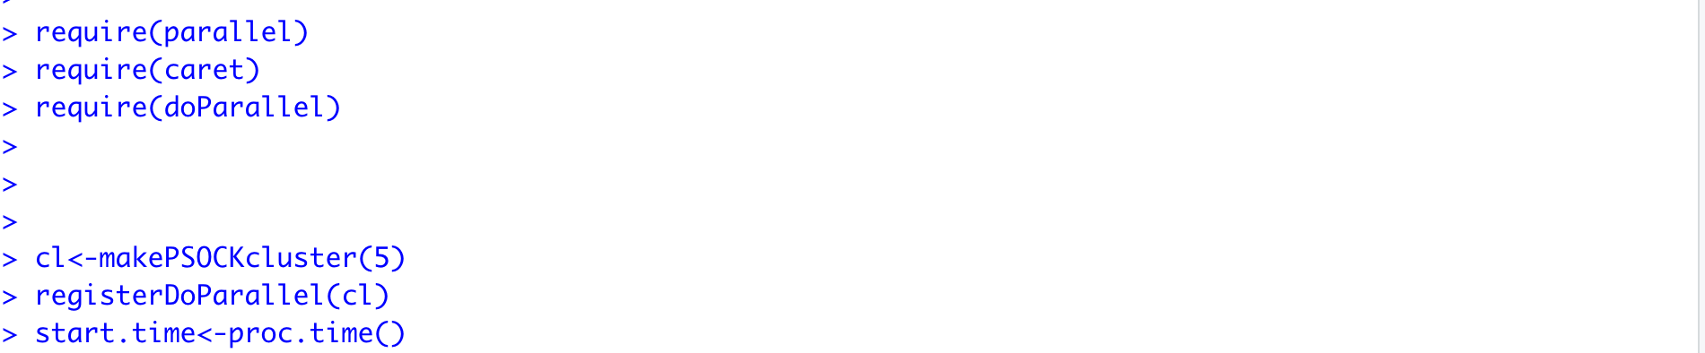

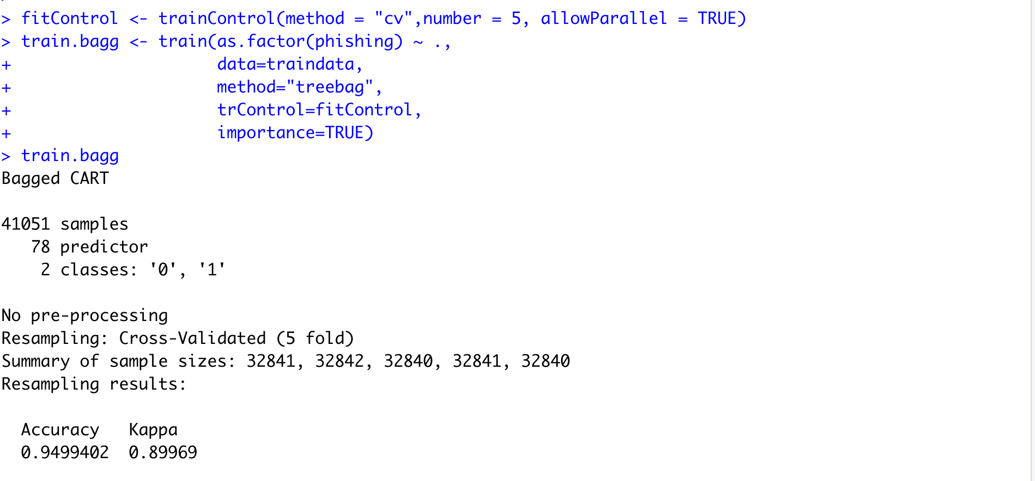

Learning Phase Confusion Matrix on Dataset1:

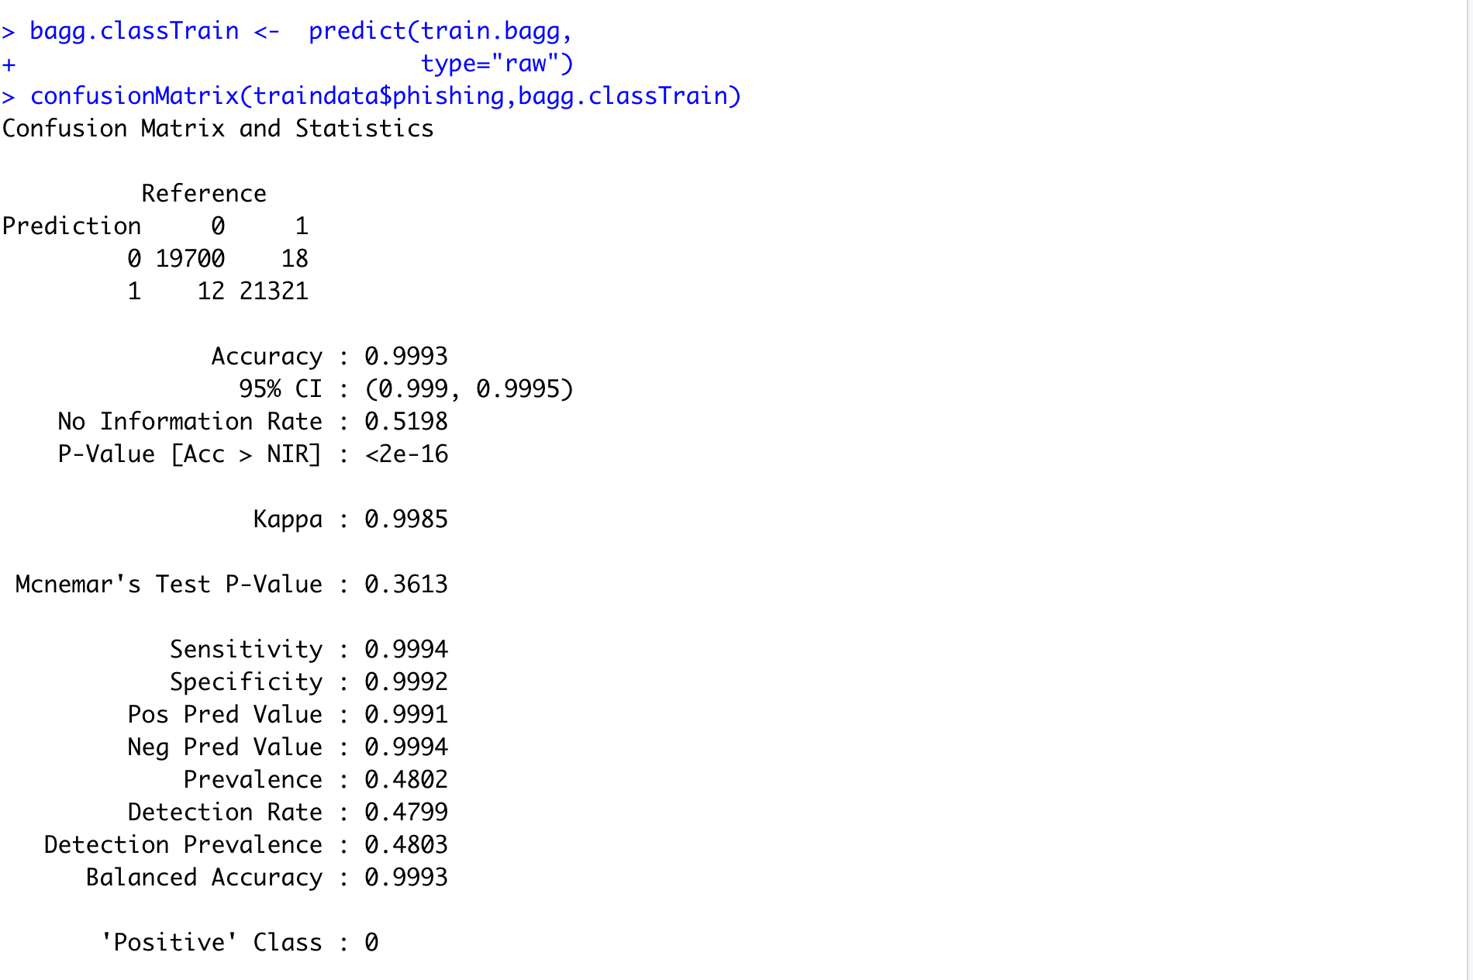

Testing Phase Confusion Matrix on Dataset1:

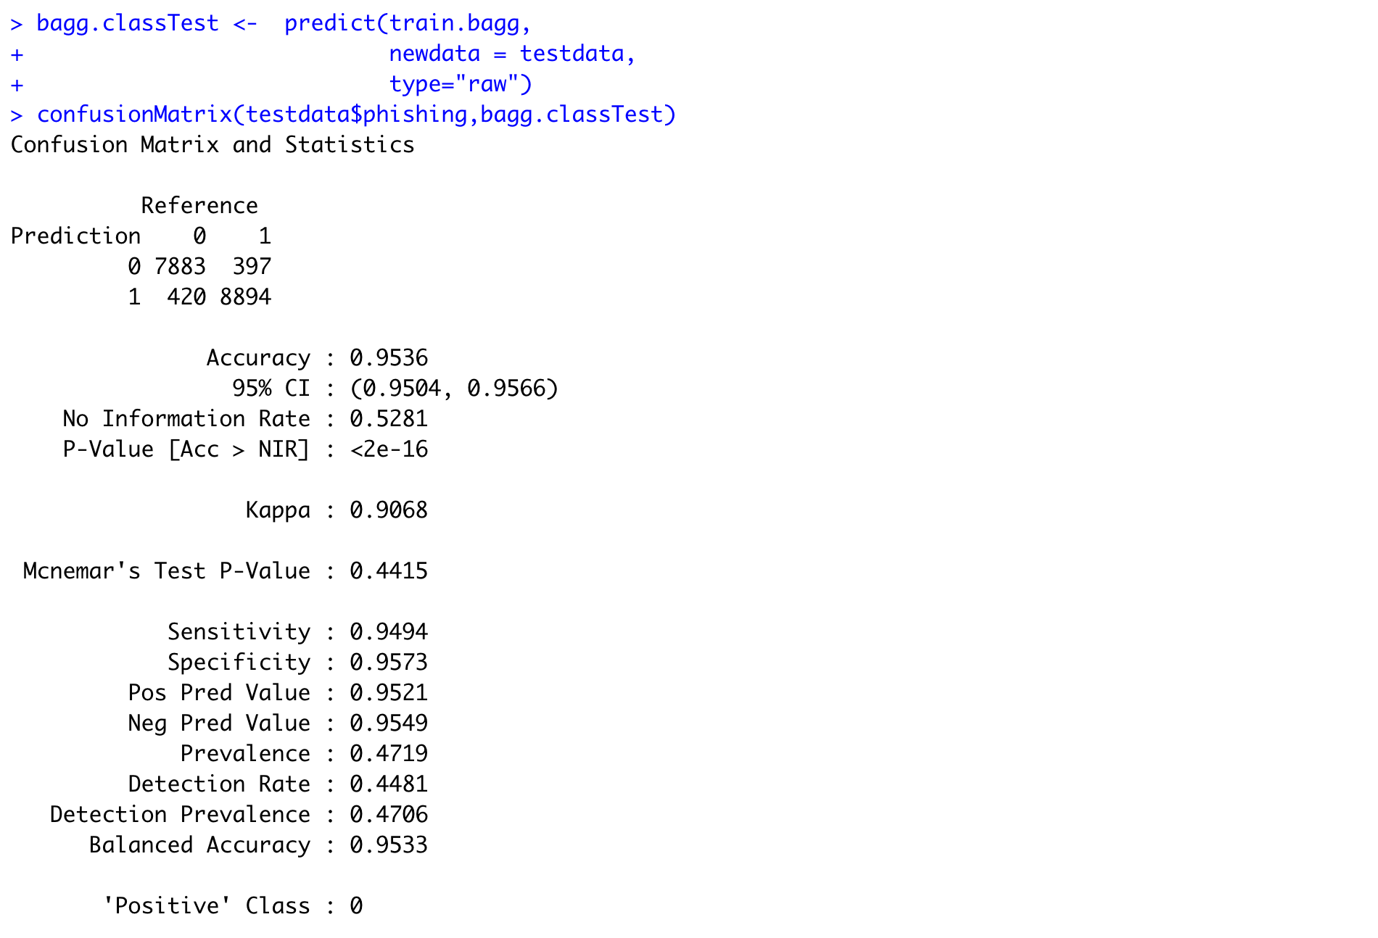

Learning Phase Bagging on Dataset2:

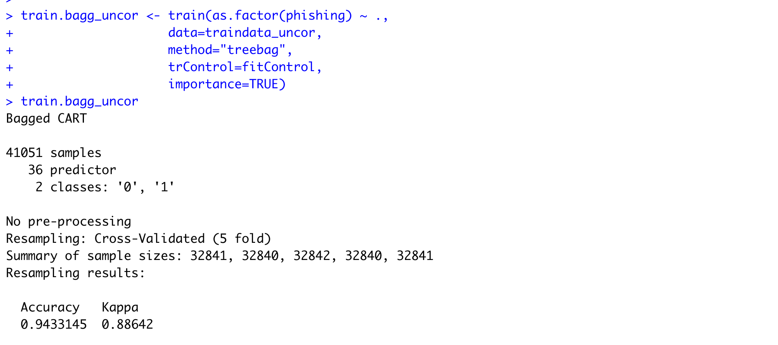

Learning Phase Confusion Matrix on Dataset2:

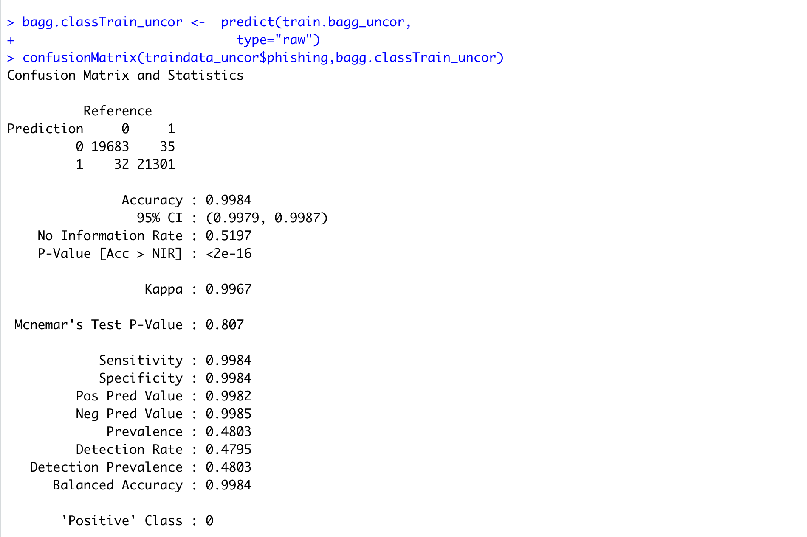

Testing Phase confusion matrix on Dataset2:

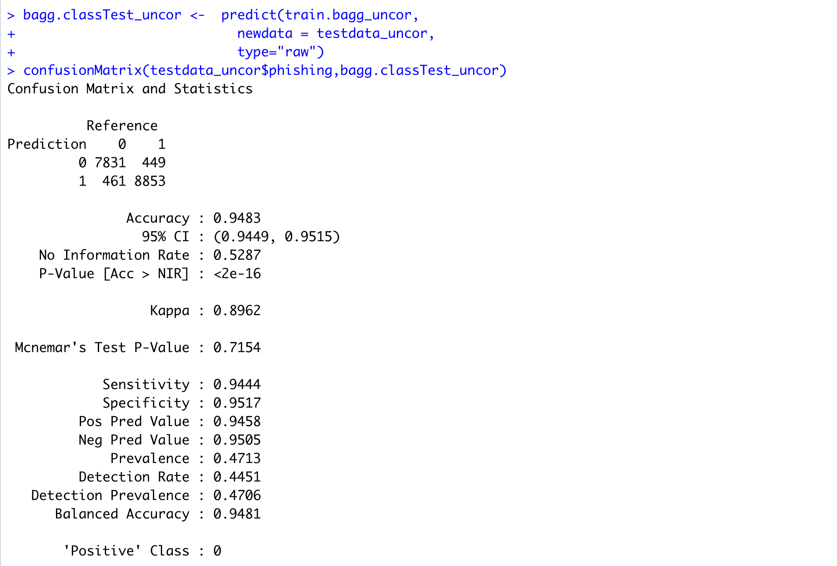

The bagging model achieved excellent accuracy in the testing phases on both the datasets. It also executes fast on large datasets.

**Section 5 – Estimating Variance of Classification Models**

We can estimate the variance of the classifiers by running the models multiple times and calculating the variance of the mean of accuracies. For this, we split the dataset into train and test datasets in 90:10 ratio where 90 percent is reserved for training and 10 percent is reserved for testing.

We calculate approximate variances for logistic regression and KNN classifiers by the below implementation.

Variation Estimation for Logistic Regression on Dataset1:



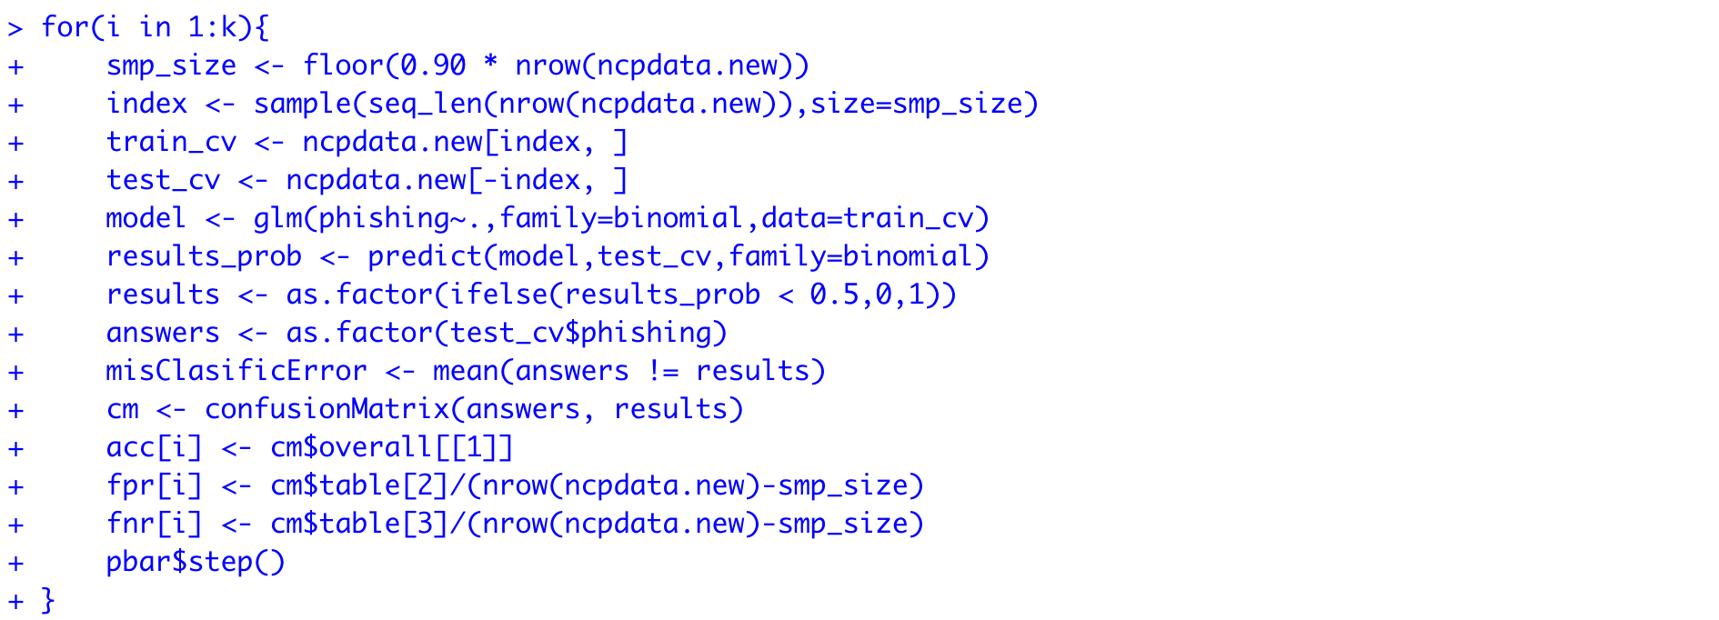



Variation Estimation for Logistic Regression on Dataset1:

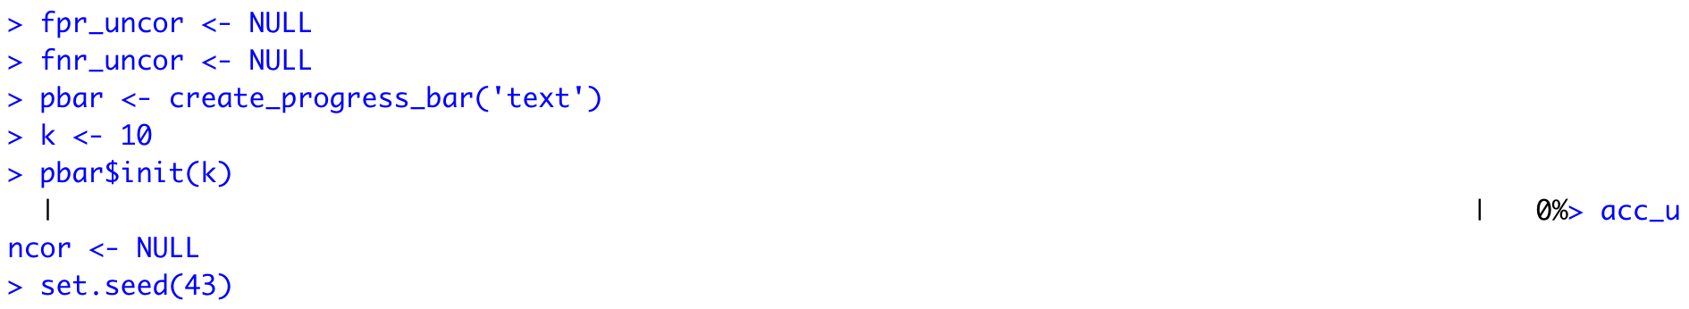

Variation Estimation for Logistic Regression on Dataset2:

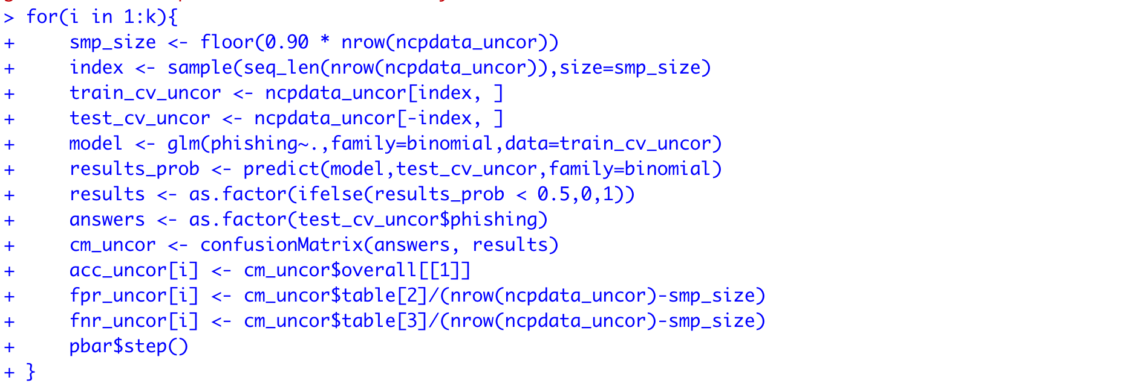



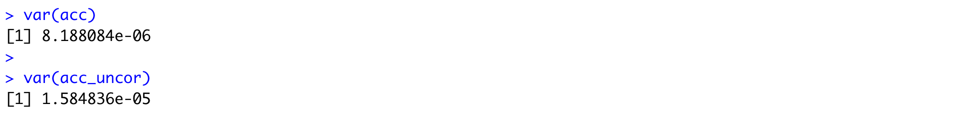

Plotting accuracies for the 2 datasets.



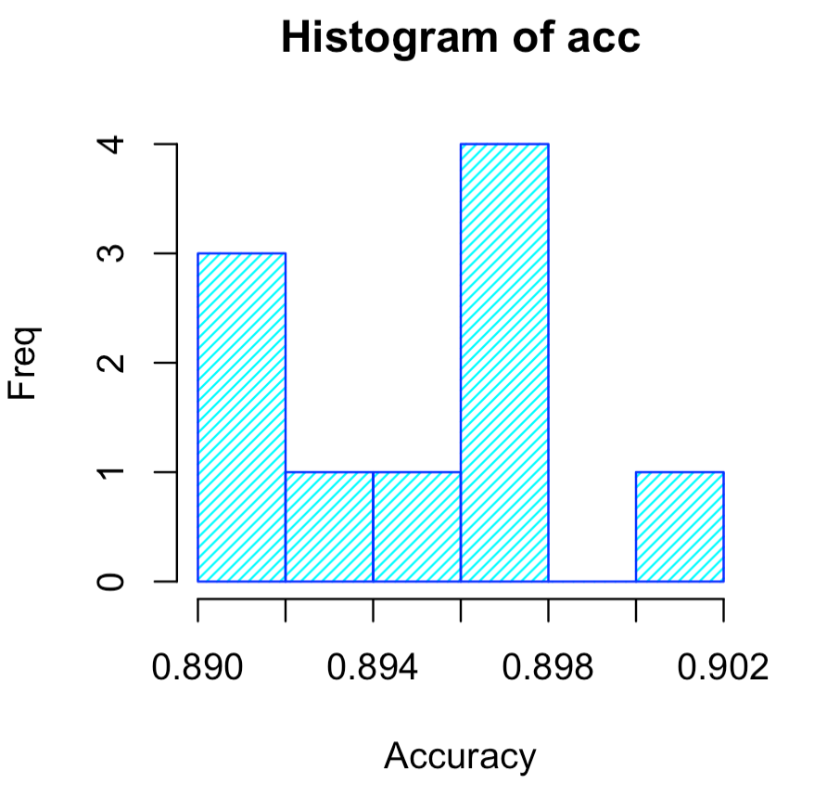

Fig: Accuracy graph for Dataset1(LR)



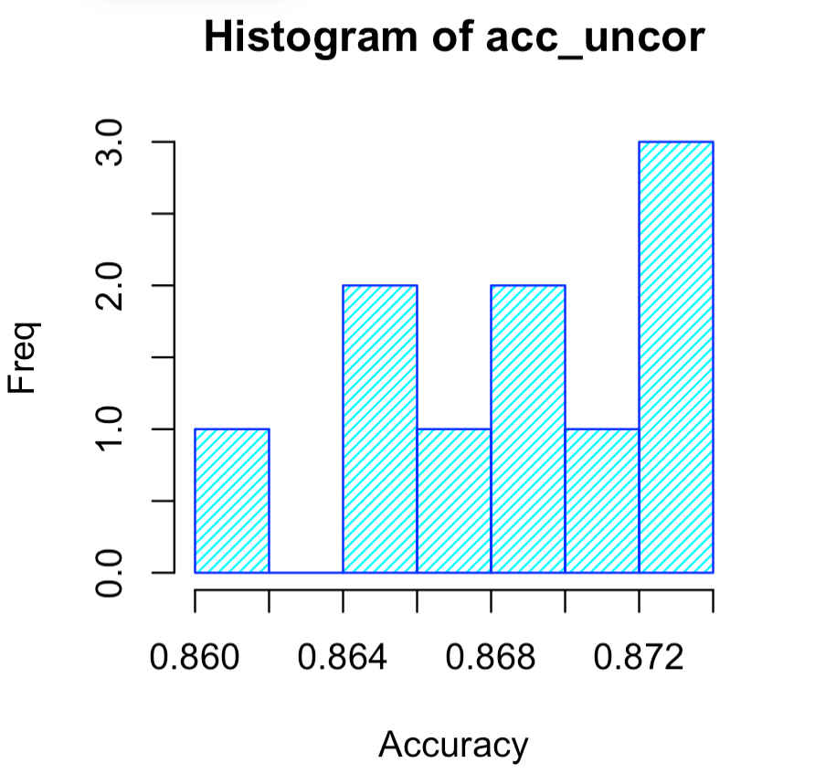

Fig: Accuracy graph for Dataset2(LR)

We repeat the same procedure but for the KNN classifier.

Variation Estimation for KNN on Dataset1:

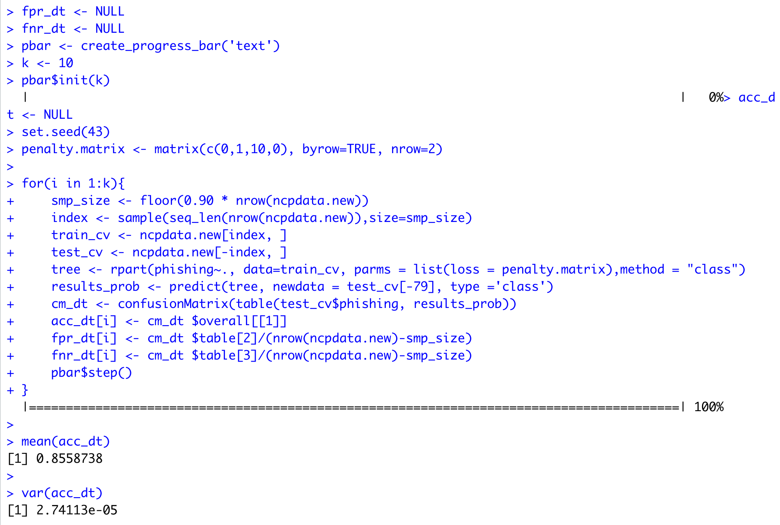

Variation Estimation for KNN on Dataset2:

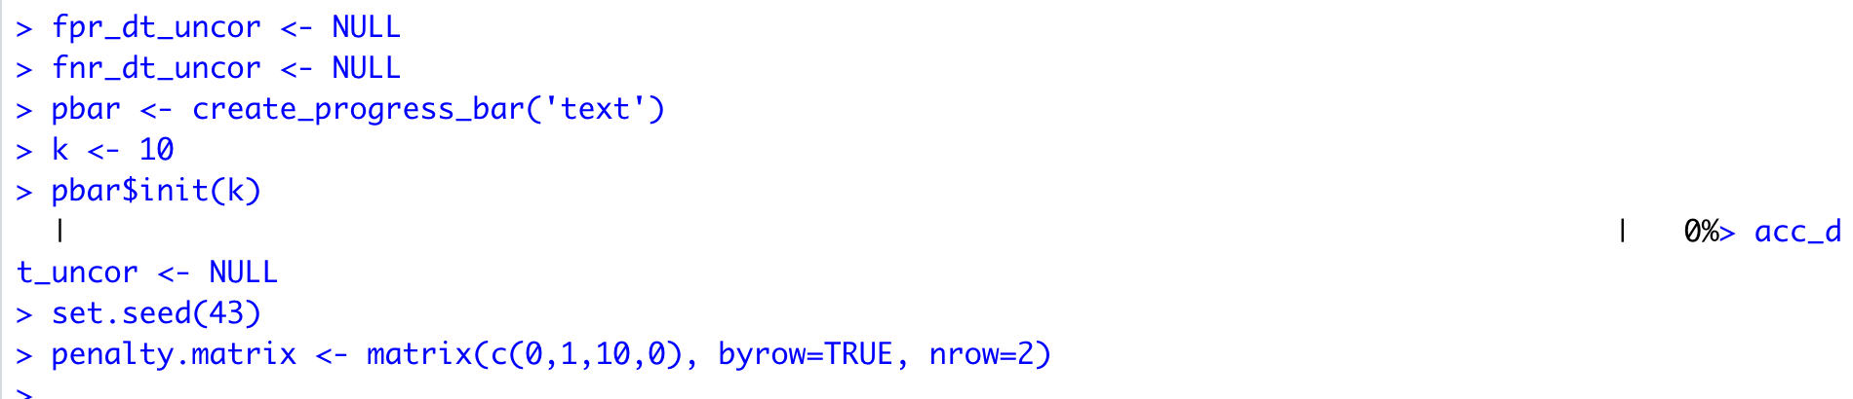

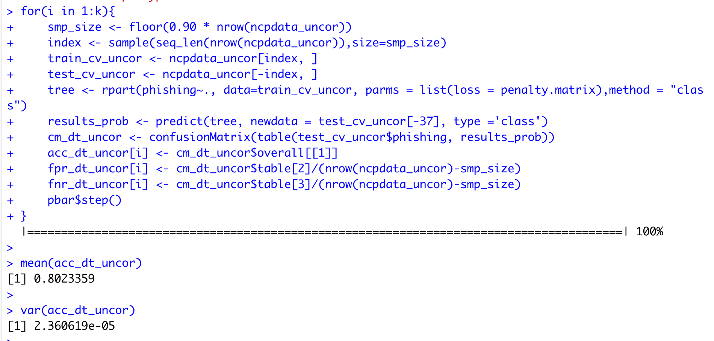

Plotting accuracies for the 2 datasets.

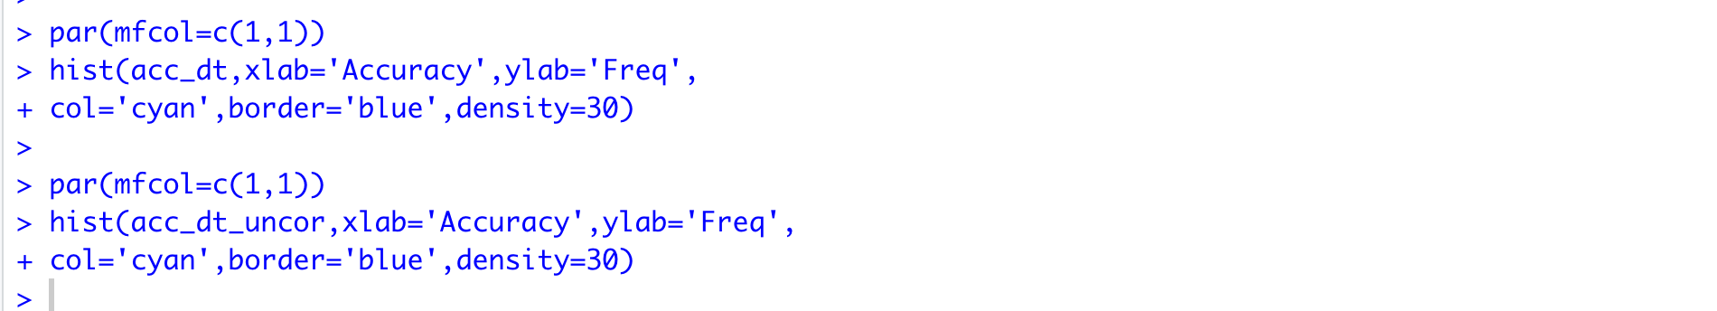

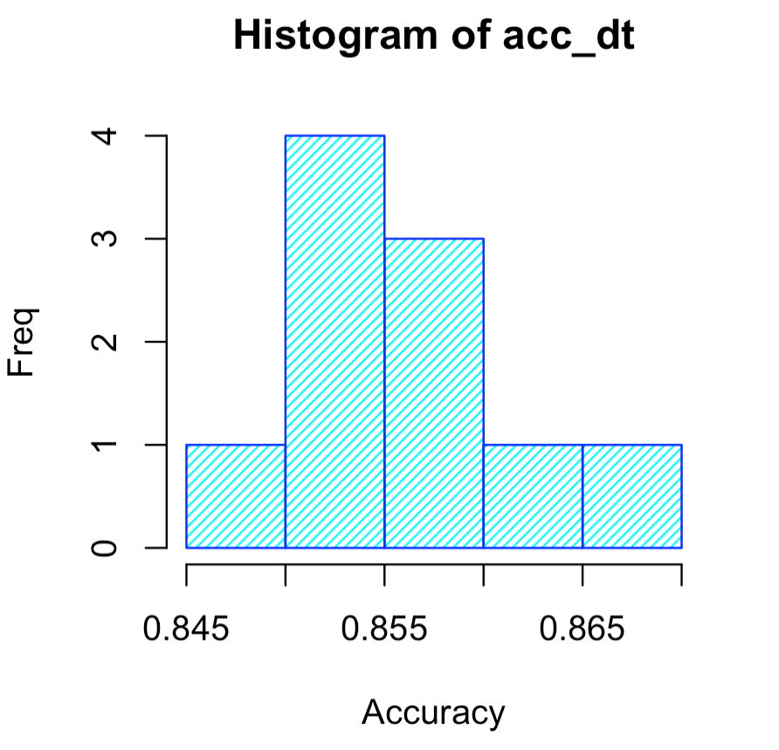

Fig: Accuracy graph for Dataset1(KNN)

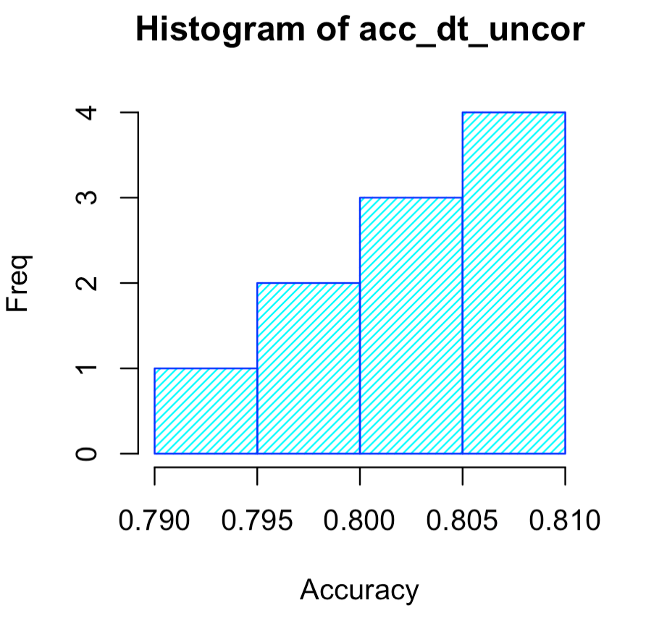

Fig: Accuracy graph for Dataset2(KNN)

We observe from running the above code that the Logistic Regression and KNN Classification models on our dataset produce very little variance which indicates a good fit on our models.

**Section 6 - Summary of Ensemble Models**

We have run Random Forest and Stacking with Cross Validation on our 2 variants of the Dataset. The summary of testing accuracies is tabulated below:

|  |  |  |
| --- | --- | --- |
| Model | Dataset1 | Dataset2 |
| Testing Accuracy | Testing Accuracy |
| Random Forest – ntree=500 | 95.78 | 95.31 |
| Random Forest – ntree=100 | 95.76 | 95.25 |
| Stacking with CV | 91.24 | 90.05 |
| Bagging with CV | 95.36 | 94.83 |

A similar conclusion can be draw from these observations as well. The larger dataset has higher accuracy when compared to the dataset with lesser observations.

Random Forest performed the best when compared to Stacking and Bagging. The individual classifier models have very low variance as indicated by the variance of accuracies above. This implies that the models are not overfitting and models were able to ideally train on the datasets.

PS: Thank You Note

I sincerely thank Professor Dr. Raman for giving me an opportunity to be a part of this course which has been an amazing journey and a great learning experience inclined towards the industry practices.